

oneM2M
Technical Report
Document Number | TR-0020-V0.8.0
Document Name: | Study of service transactions and re-usable service layer context
Date: | 2017-June-02
Abstract: | The document is a study of transaction as well as re-usable service layer context. The key objective and value is analyzed and described. The document also investigates the potential solution in oneM2M by evaluating the existing technical solutions.
Template Version:23 February 2015 (Dot not modify)

This Specification is provided for future development work within oneM2M only. The Partners accept no liability for any use of this Specification.
The present document has not been subject to any approval process by the oneM2M Partners Type 1. Published oneM2M specifications and reports for implementation should be obtained via the oneM2M Partners' Publications Offices.

About oneM2M
The purpose and goal of oneM2M is to develop technical specifications which address the need for a common M2M Service Layer that can be readily embedded within various hardware and software, and relied upon to connect the myriad of devices in the field with M2M application servers worldwide.
More information about oneM2M may be found at: http//www.oneM2M.org
Copyright Notification
© 2015, oneM2M Partners Type 1 (ARIB, ATIS, CCSA, ETSI, TSDSI, TIA, TTA, TTC).
All rights reserved.
The copyright and the foregoing restriction extend to reproduction in all media.

Notice of Disclaimer & Limitation of Liability
The information provided in this document is directed solely to professionals who have the appropriate degree of experience to understand and interpret its contents in accordance with generally accepted engineering or other professional standards and applicable regulations. No recommendation as to products or vendors is made or should be implied.
NO REPRESENTATION OR WARRANTY IS MADE THAT THE INFORMATION IS TECHNICALLY ACCURATE OR SUFFICIENT OR CONFORMS TO ANY STATUTE, GOVERNMENTAL RULE OR REGULATION, AND FURTHER, NO REPRESENTATION OR WARRANTY IS MADE OF MERCHANTABILITY OR FITNESS FOR ANY PARTICULAR PURPOSE OR AGAINST INFRINGEMENT OF INTELLECTUAL PROPERTY RIGHTS. NO oneM2M PARTNER TYPE 1 SHALL BE LIABLE, BEYOND THE AMOUNT OF ANY SUM RECEIVED IN PAYMENT BY THAT PARTNER FOR THIS DOCUMENT, WITH RESPECT TO ANY CLAIM, AND IN NO EVENT SHALL oneM2M BE LIABLE FOR LOST PROFITS OR OTHER INCIDENTAL OR CONSEQUENTIAL DAMAGES. oneM2M EXPRESSLY ADVISES ANY AND ALL USE OF OR RELIANCE UPON THIS INFORMATION PROVIDED IN THIS DOCUMENT IS AT THE RISK OF THE USER.

Contents
Contents 3
1 Scope 5
2 References 5
2.1 Normative references 5
2.2 Informative references 5
3 Definitions, symbols and abbreviations 5
3.1 Definitions 5
3.2 Symbols 6
3.3 Abbreviations 6
4 Conventions 6
5 Introduction to transaction and re-useable service layer context 6
5.1 Transaction 6
5.1.1 Overview 6
5.1.2 The ACID characteristic of transaction 7
5.1.3 Transactions in M2M 7
5.2 Re-usable service layer context 7
5.2.1 Overview 7
5.2.2 Use Cases analysis 8
6 Analysis of existing technologies 8
6.1 Transaction 8
6.1.1 1PC (1 Phase Commit protocol) 8
6.1.2 2PC (2 Phase Commit protocol) 8
6.1.3 3PC (3 Phase Commit protocol) 9
6.1.4 TCC (Try confirm cancel) 9
7 Referencing architecture and major features 10
7.1 Transaction 10
7.1.1 Existing requirements 10
7.1.2 Transaction 10
7.2 Re-usable service layer context 10
7.2.1 Existing Requirements 10
7.2.2 Service layer context management 11
8 Potential Solutions in oneM2M 12
8.1 Transaction 12
8.1.1 Solution #1 12
8.1.1.1 <transaction> resource 12
8.1.1.2 Transaction handling 13
8.1.1.3 <transaction> Resource Procedures 15
8.1.1.3.1 Create <transaction> 15
8.1.1.3.2 Update <transaction> 15
8.1.1.3.3 Retrieve <transaction> 16
8.1.1.3.4 Delete <transaction> 16
8.1.2 Solution #2 16
8.1.2.1 transactionFanOutPoint 16
8.1.3 Solution #3 18
8.1.3.1 Overview 18
8.1.3.2 <transactionMgmt> resource 19
8.1.3.3 <transaction> resource 22
8.1.4 Solution #4 23
8.1.4.1 Overview 23
8.1.4.2 <transactionMgmt> resource 24
8.1.4.3 <transactionFanOutPoint> resource 30
8.1.4.4 <transaction> resource 32
8.2 Re-usable service layer context 36
8.3 Support for Realtime Multimedia Sessions 36
8.3.1 Roles of M2M Nodes to support multimedia sessions 36
8.3.2 Real time Multimedia Session examples 39
8.3.2.1 Example 1 - Establishing Multimedia Session between ADN-AEs via IN-CSE 39
8.3.2.3 Example 3 – Updating an Established Multimedia Session 45
8.3.3 Resource Types To Support Real Time Streaming Sessions 47
8.3.3.1Resource Type multimediaSession 47
8.3.4 Procedures 49
8.3.4.1 <multimediaSession> Resource Procedures 49
8.3.4.1.1 Create <multimediaSession> 49
8.3.4.1.2 Retrieve < multimediaSession > 50
8.3.4.1.3 Update < multimediaSession > 50
8.3.4.1.4 Delete <multimediaSession> 52
8.3.5 Changes to existing Resources in TS-0001 53
Proforma copyright release text block 61
Annexes 61
Annex <y>: Bibliography 62
History 62

1 Scope
The present document is a study of transaction as well as re-usable service layer context. The key objective and value is analyzed and described. The document also investigates the potential solution in oneM2M by evaluating the existing technical solutions.

2 References
The following text block applies.
References are either specific (identified by date of publication and/or edition number or version number) or non-specific. For specific references,only the cited version applies. For non-specific references, the latest version of the referenced document (including any amendments) applies.

2.1 Normative references
As a Technical Report (TR) is entirely informative it shall not list normative references.
The following referenced documents are necessary for the application of the present document.
Not applicable.

2.2 Informative references
Clause 2.2 shall only contain informative references which are cited in the document itself.
The following referenced documents are not necessary for the application of the present document but they assist the user with regard to a particular subject area.
[i.1] oneM2M Drafting Rules (http://member.onem2m.org/Static_pages/Others/Rules_Pages/oneM2M-Drafting-Rules-V1_0.doc)
[i.2] oneM2M TS-0001_Functional_Architecture
[i.3] 3GPP TS 29.336: Home Subscriber Server (HSS) diameter interfaces for interworking with packet data networks and applications (Release 13).

3 Definitions, symbols and abbreviations
Delete from the above heading the word(s) which is/are not applicable.

3.1 Definitions
Clause numbering depends on applicability.
- A definition shall not take the form of, or contain, a requirement.
- The form of a definition shall be such that it can replace the term in context. Additional information shall be given only in the form of examples or notes (see below).
- The terms and definitions shall be presented in alphabetical order.
For the purposes of the present document, the [following] terms and definitions [given in ... and the following] apply:
Definition format
<defined term>: <definition>
If a definition is taken from an external source, use the format below where [N] identifies the external document which must be listed in Section 2 References.
<defined term>[N]: <definition>
example 1: text used to clarify abstract rules by applying them literally
NOTE: This may contain additional information.

3.2 Symbols
Clause numbering depends on applicability.
For the purposes of the present document, the [following] symbols [given in ... and the following] apply:
Symbol format
<symbol> <Explanation>
<2nd symbol> <2nd Explanation>
<3rd symbol> <3rd Explanation>

3.3 Abbreviations
Abbreviations should be ordered alphabetically.
Clause numbering depends on applicability.
For the purposes of the present document, the [following] abbreviations [given in ... and the following] apply:
Abbreviation format
<ABBREVIATION1> <Explanation>
<ABBREVIATION2> <Explanation>
<ABBREVIATION3> <Explanation>

4 Conventions
The key words “Shall”, ”Shall not”, “May”, ”Need not”, “Should”, ”Should not” in this document are to be interpreted as described in the oneM2M Drafting Rules [i.1]

5 Introduction to transaction and re-useable service layer context
Editor’sNote: The clause describes use cases and the key objectives and values of transaction and re-usable service layer context. Analyses what benefit could such technology bring to service providers.

5.1 Transaction

5.1.1 Overview
Transaction is a set of operation or a sequence of operation that has to be performed as a unit. The set of operations are closely related by business or service association that as a unit, they need to be either to be executed all successfully or none of them are successfully executed.
The recepient of a transaction could be multiple devices which in this case is a distributed transaction or a single device. The issuer of a transaction is usually a coordinator that starts and commits or rolls back a transaction.
In the distributed transaction case, a transaction is composed of multiple requests dedicated to different devices. The request targeting at different device are independent and are not aware of each other. It’s the coordinator’s responsibility to guarantee the consistency between multiple requests.
In the centralized case, a transaction is composed of a sequence of requests to a single server. The sequence of requests has to be executed one by one by the server in a predefined order. And as a transaction, they has to be guaranteed to be executed one by one. If either of the request failed, all requests has to be rolled back and return the server to the initial state.
The two cases may be combined according to service requirements.
Transaction is now widely used in banking systems, data bases and enterprise systems. For example, in a account transfer operation, the withdrawing of the account and deposit of the other account has to be executed as if it’s one single request although the operation is composed of two separate requests. In this case, any middle state is not allowed.

5.1.2 The ACID characteristic of transaction
Transaction has four characteristics which are atomicity, consistency, isolation and durability (ACID).
Atomicity means no matter how many requests or steps a transaction has, they have to be executed as if it is one single request. They have to be all successful or all failure. None of the middle state is allowed.
Consistency means that the data or state of the server has to be consistent before and after the execution of an transaction. Consistency is closely related with atomicity. For example in the withdraw and deposit transaction, the total ammount of credit before and after the transaction has to be the same. Either of the middle state would mean the unexpected increase or decrease of the credit which is not allowed.
Isolation means that transactions need to be isolated with each other and they cannot interference with each other. Locks are usually used to guarentee the isolation of transaction.
Durability means that once a transaction is commited. The system need to guarentee that the result of the transaction is safe and durable. The result is capable of withstanding sudden malfunction and is able to recover to the result after recovery.

5.1.3 Transactions in M2M
Transaction is also very important in M2M/IoT. In M2M businesses, some of the requests to devices need to have atomocity and consistency. For example in a device hardware upgrade operation, in order to guarentee the interoperability of multiple devices, it is required that the devices to be upgraded together. If only part of the devices are upgraded but not the others, there may be interoperate problems. Isolation and duration are also needed by M2M systems. For example, in device management, the upgrade of different parts of software could be part of multiple transactions. The trasaction has to be isolated to protect the consistency of the device. And the result of the upgrade need to be durable as well.

5.2 Re-usable service layer context

5.2.1 Overview
oneM2M service can support to re-use the context established between M2M service layer instances over multiple hops, for example, between M2M applications to a M2M service layer instance, or between service layer instances. oneM2M system has implemented sessionless hop-by-hop communication at service layer, but lacks corresponding mechanism to manage multi-hops communication that is regardless of underlying network connection.
Restful is stateless, and could not be constrained by context . However service session may include more than one operation, such as control the temperature in the room according to indication of thermometer. oneM2M service layer context can be stored for maintaining communication within the whole session. The context can consist of M2M service layer state, communication states, security information, underlying network information, QoS parameters etc. For some services that required higher quality of service, such as video surveillance, patient monitoring, and emergency services that are described in TR 0001, the context can be provide QoS parameters and more information of enhancing QoS and service layer analytics. What is more, the context is reusable for reducing extra overhead, especially on constrained devices.

5.2.2 Use Cases analysis
The collection use cases from TR-0001 have re-useable service layer context aspects:
- Secure remote patient care and monitoring (see TR-0001, section 7.3).
- Real Time Audio/Video Communication (see TR-0001, section 9.4).

6 Analysis of existing technologies
Editor’s Note: the clause gives some examples of the existing technology.

6.1 Transaction

6.1.1 1PC (1 Phase Commit protocol)
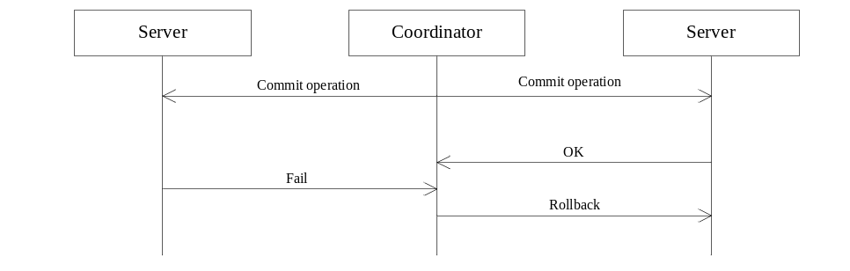

Figure 6.1.1-1: 1PC protocol
In the 1 phase commit protocol, the coordinator commits an operation to the servers that are part of the transaction. The server executes the operation if all conditions are met. If either of the server failed to commit the operation, after receiving the fail response, the coordinator send rollback request to those servers who have successfully committed the operation.

6.1.2 2PC (2 Phase Commit protocol)
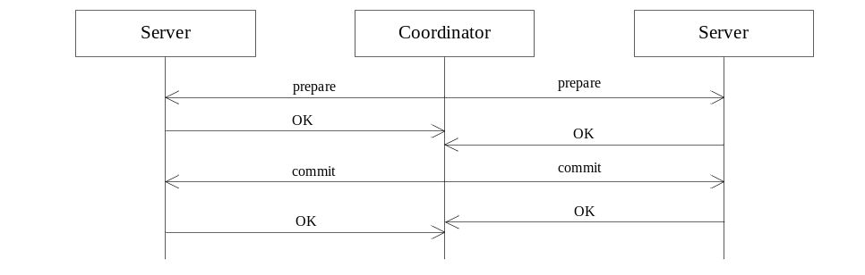

Figure 6.1.2-1: 2PC protocol
In the 2 phase commit protocol, the transaction is composed of two phases, the preparation phase and the commit phase. In the preparation phase, the coordinator sends prepare request to servers. Based on the local context of the servers, the servers respond to the coordinator if the request can be executed or not. If the server responded OK in the first phase, the server is guarenteed that the commit request can be executed. If all servers respond OK in the preparation phase, the coordinator would send commit request to the participants to commit the prepared request. If either of the server responded fail in the preparation phase, the coordinator would send abort request to participants to abort the transaction.

6.1.3 3PC (3 Phase Commit protocol)
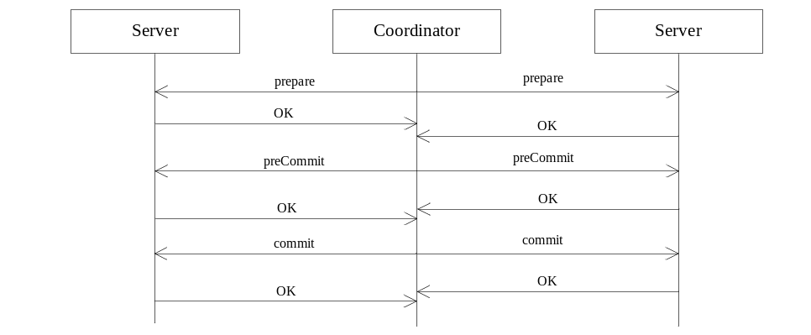

Figure 6.1.2-1: 3PC protocol
In the 3PC protocol, the only different between the 2PC protocol is the handling of time out. Between preparation phase and commit phase, a pre-commit phases is added to guide the servers action when timeout happens. In the preparation phase, if timeout happens, the server will automaticlly abort the transaction. In the pre-commit phase, if time out happens, the server will automaticlly commit the transaction.

6.1.4 TCC (Try confirm cancel)
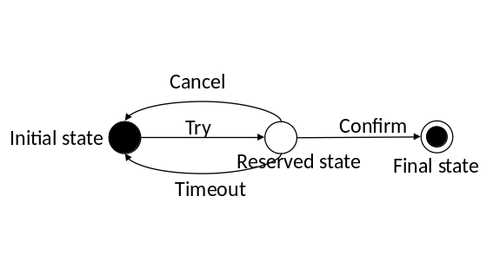

Figure 6.1.4-1: TCC method
In the TCC method, the transaction is composed of three phases.
In the Try phase, the application tries to update resources distributed on different servers. In the update request, the application provides an expiration time. The server then checks if the server can perform the request. If the checking is successful, the server responds an successful response and goes into reserved state. Otherwise, the server rejects the request. In case the server hasn’t received any confirm request in the reserved state, the server goes back to Initial state after timeout.
In the Confirm phase, if application finds that all servers related to the distributed transaction has successfully went into reserved state, the application sends confirm message to all the servers. Upon receiving the confirm message, the server make change to the resource and goes into final state.
In the Cancel phase, if any of the server rejects in the try phase and the application determined to abandon the transaction, the application simply bypasses the confirm phase. If the server doesn’t receive any confirm message during the expiration time, the server cancels the transaction automatically.
The benefit of TCC method is that the server doesn’t need to wait for the abort message if anything happened in the transaction. But the server still need to keep a reserved state for the successful execution of a transaction.

7 Referencing architecture and major features
Editor’s Note: this clause describes the referencing architecture of transaction and re-usable service layer context. The major features of the two functions.

7.1 Transaction

7.1.1 Existing requirements
In TS-0001, there are two requirements related to transaction that are not yet implemented by the specification.
Requirement ID | Description | Release
OSR-073  See REQ-2015-0529R03 | The oneM2M System shall support distributed transactions to multiple devices or applications where the transaction includes the characteristics of atomicity, consistency, isolation and durability. | Not implemented
OSR-074  See REQ-2015-0529R03 | The oneM2M System shall support the completion of distributed transactions to multiple devices or applications while maintaining the order of the operations and performing the transaction within a given time frame. | Not implemented

7.1.2 Transaction
oneM2M is a resource oriented architecture. All functions are implemented by addressing resources. In a transaction, application need to coordinate requests addressing different resource hosting CSEs. As a part of transaction, the before actually executing the request, the hosting CSE need to pre-assure the request is guaranteed to be performed when the application tells the hosting CSE to do so. As a result, the hosting CSE need to maintain a state that the resource goes into a reserved state. And before the reserved state is released, the hosting CSE need to lock the resource to guarantee the assurance that the hosting CSE can execute the request won't be affected by any intermediate requests. Then when the application comits the transaction, the Hosting CSE is always guaranteed that the request can be executed successfully.
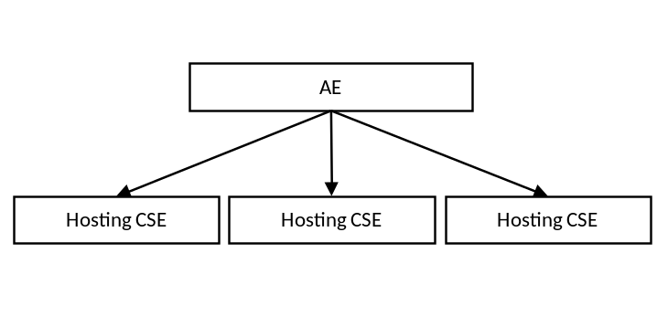

Figure 7.1.2-1: Referencing architecture of Transaction

7.2 Re-usable service layer context

7.2.1 Existing Requirements
In TS-0002 Requirement there are three requirements requiring service layer multi-hop communications and QoS are not yet fulfilled.
NO | Requirement | Status
OSR-003 | The oneM2M System shall support the ability to maintain peer-to-peer M2M Session in coordination with application session for those M2M Applications that require it. | Partially implemented in Rel-1  (see note 21)  NOTE 21: No support for peer-to-peer service layer session.
CRPR-005 | The oneM2M System shall be able to maintain context associated with M2M sessions (e.g. security context or network connectivity context during the interruption of the session). | Partially implemented in Rel-1  (see note 1)  NOTE 1: Long lived security context and registration is covered, M2M Sessions are not covered.
OSR-042 | The oneM2M System shall be able to support different QoS-levels specifying parameters, such as guaranteed bitrate, delay, delay variation, loss ratio and error rate, etc. | Not implemented in Rel-1

7.2.2 Service layer context management
For a service layer session, a context is eastablished between the oneM2M service layer instances (AEs/CSEs). As depicited in the figure 7.2.2-1, the SCM (Sevice layer context management) is a new service function residing in the CSE to provide end-to-end session related context management at the service layer, and exposed to the AE via Mca, or the CSE via Mcc. The SCM supports a service layer session related context that spans multiple CSE hops.

The SCM includes capabilities such as:
- service layer context establishment and termination,
- management of context and services related to the session,
- analysis of service layer context.

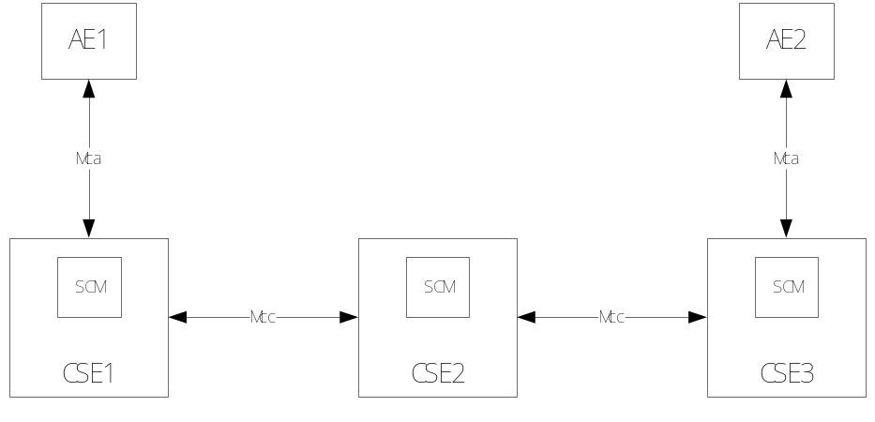
Figure7.2.2-1 Service layer context management demonstration
A service layer session consists of a sequence of requests and corresponding responses made by the same end points (AE/CSE). The SCM shall support the context ,e.g. configuration for multiple session participants or information related to the M2M service session activity that has occurred. The context is established at beginning of the session in accordance with a request from the AE/CSE. The context is configured and managed by the SCM until the session termination. The SCM shall support the context to be provided/exposed to other CSFs in the CSE or other AEs/CSEs for reuse in the session.

8 Potential Solutions in oneM2M
Editor’s Note: this clause propose the enhancements based on architecture defined by oneM2M. What mechanisms can be reused and what need to be newly defined.

8.1 Transaction

8.1.1 Solution #1

8.1.1.1 <transaction> resource
An <transaction> resource could be child resouce of any resource. It indicates that the parent resource is apart of a transaction. According to the information in the <transaction> resource, the parent resource is changed.
The <transaction> resource shall contain the child resources specified in table 8.1.1.1-1.
Table 8.1.1.1-1: Child resources of <transaction> resource
Child Resources of <transaction> | Child Resource Type | Multiplicity | Description
[variable] | <subscription> | 0..n | See clause 9.6.8 [i.2].

The <transaction> resource shall contain the attributes specified in table 8.1.1.1-1.
Table 8.1.1.1-1: Attributes of <transaction> resource
Attributes of  <transaction> | Multiplicity | RW/  RO/  WO | Description
resourceType | 1 | RO | See clause 9.6.1.3[i.2].
resourceID | 1 | RO | See clause 9.6.1.3[i.2].
resourceName | 1 | WO | See clause 9.6.1.3[i.2].
parentID | 1 | RO | See clause 9.6.1.3[i.2].
expirationTime | 1 | RW | See clause 9.6.1.3[i.2].
accessControlPolicyIDs | 0..1 (L) | RW | See clause 9.6.1.3[i.2].
creationTime | 1 | RO | See clause 9.6.1.3[i.2].
lastModifiedTime | 1 | RO | See clause 9.6.1.3[i.2].
labels | 0..1 (L) | RW | See clause 9.6.1.3[i.2].
state | 1 | RO | The current state of the transaction. It could be  Initial state: if the Hosting CSE hasn’t determined that the transaction can be executed or not.  Reserved state: if the Hosting CSE has finished the checking and guaranteed the transaction can be executed at the given execution time.  Final state: if the Hosting CSE has successful executed the transaction.
executionTime | 1 | RW | The intended execution time of the transaction. The Hosting CSE executes the primitive contained in the <request> child resource at the time specified by the attribute.
primitive | 1 | WO | The attribute is a complex data type that carries the primitive that is operated on the parent resource of the <transaction> resource. The primitive attribute includes information about the operation, originator, primitiveContent.

8.1.1.2 Transaction handling
The following diagram show the flow how a transaction is commited in using <transaction> resource in oneM2M. In a transaction, one AE and multiple CSEs are involved. The AE need to coordinate transaction among multiple CSEs. An AE need to send operation to resource hosted on multiple CSEs. The AE requires the multiple CSEs either excute the operation successfully or none of them execute the operation.
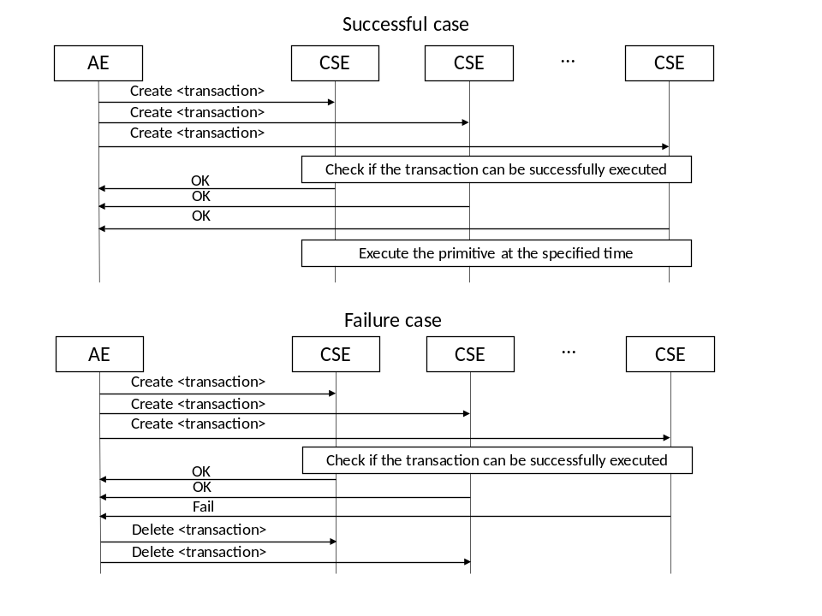
Figure 8.1.1.2-1: Transaction procedure
Step 1: AE creats <transaction> resource as child resource to multiple resources according to the requirement of the service. The <transaction> resource contains the execution time of the transaction as well as the primitive to be executed. The execution time of different CSEs is the same to guarantee the commit of transaction is cooridinated. The primitive further contains the originator’s identity, the operation and the content of the primitive to be executed. The <transaction> resources to be created on different CSEs could be different.
Step 2: At each CSE that has received the <transaction> creation request, the CSE checks if the <transaction> can be successfully executed. The content of the checking may include the access right, the format of the primitive is correct, the execution can be performed at the specified time and other necessary criterias that are critical to the success of the primitive.
Step 3 (Success): If the checking is successful, the CSE responds created to the AE and make the parent resource of <transaction> resource into reserved state. In the reserved state, the resource will refuse any other request that will potentially break the affect the success of execution of the primitive at the specified execution time.
Step 4 (Success): At the specified execution time, the CSEs will individually execute their corresponding primitive.
Step 3 (Failure): If the checking at any one of the CSE has failed, the CSE responds a failed response to the AE. On receiving the failed response, the AE determines that the transaction cannot be commited any more, thus send delete <transaction> to those CSEs which have successfully created the <transaction> resource to cancel the transaction.
Step 4 (Failure): The CSE which has successfully created the <transaction> deletes the transaction.
Optional additional steps:
Step 3 (Failure): On receiving the failed response, the AE may decide if the <transaction> could be created again at the failed CSE according to the service. The re-creation of <transaction> should be within the time of the given execution time.

8.1.1.3 <transaction> Resource Procedures

8.1.1.3.1 Create <transaction>
Table 8.1.1.3.1-1: <transaction> CREATE
<transaction> CREATE
Associated Reference Point | Mca, Mcc and Mcc'
Information in Request message | All parameters defined in table 8.1.2-3[i.2] apply with the specific details for:  Content: The representation of the <transaction> resource described in clause 8.1.1
Processing at Originator before sending Request | According to clause 10.1.1.1[i.2]  The Originator is the AE that coordinates the transaction according to the requirement of from the services.
Processing at Receiver | According to clause 10.1.1.1[i.2]  The Receiver checks if the primitive in the <transaction> resource could be successfule executed at the given executionTime in the <transaction> resource. On successful check, the receiver responds OK to the originator. Otherwise, the request is rejected.
Information in Response message | All parameters defined in table 8.1.3-1[i.2] apply with the specific details for:  - Content: Address of the created <transaction> resource, according to clause 10.1.1.1[i.2]
Processing at Originator after receiving Response | According to clause 10.1.1.1[i.2]
Exceptions | According to clause 10.1.1.1[i.2]

8.1.1.3.2 Update <transaction>
Table 8.1.1.3.2-1: <transaction> UPDATE
<transaction> UPDATE
Associated Reference Point | Mca, Mcc and Mcc'
Information in Request message | All parameters defined in table 8.1.2-3[i.2] apply with the specific details for:  Content: attributes of the <transaction> resource as defined in clause 8.1.1 which need be updated
Processing at Originator before sending Request | According to clause 10.1.3[i.2]
Processing at Receiver | According to clause 10.1.3[i.2]
Information in Response message | According to clause 10.1.3[i.2]
Processing at Originator after receiving Response | According to clause 10.1.3[i.2]
Exceptions | According to clause 10.1.3[i.2]

8.1.1.3.3 Retrieve <transaction>
Table 8.1.1.3.3-1: <transaction> RETRIEVE
<transaction> RETRIEVE
Associated Reference Point | Mca, Mcc and Mcc'.
Information in Request message | According to clause 10.1.2.[i.2]
Processing at Originator before sending Request | According to clause 10.1.2. [i.2]
Processing at Receiver | According to clause 10.1.2. [i.2]
Information in Response  message | According to clause 10.1.2. [i.2]
Processing at Originator after receiving Response | According to clause 10.1.2. [i.2]
Exceptions | According to clause 10.1.2. [i.2]

8.1.1.3.4 Delete <transaction>
Table 8.1.1.3.4-1: <transaction> DELETE
<transaction> DELETE
Associated Reference Point | Mca, Mcc and Mcc'
Information in Request message | All parameters defined in table 8.1.2-3[i.2] apply.
Processing at Originator before sending Request | According to clause 10.1.4.[i.2]
Processing at Receiver | According to clause 10.1.4. [i.2]
Information in Response message | According to clause 10.1.4. [i.2]
Processing at Originator after receiving Response | According to clause 10.1.4. [i.2]
Exceptions | According to clause 10.1.4. [i.2]

8.1.2 Solution #2

8.1.2.1 transactionFanOutPoint
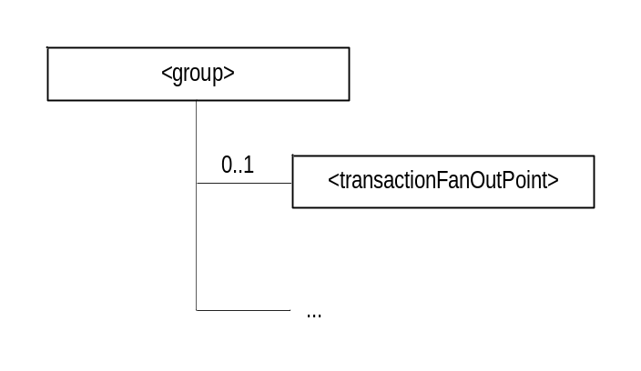
Figure 8.1.2.1-1: <transactionFanOutPoint> resource

Table 8.1.2.1-1: Child resources of <group> resource
Child Resources of <group> | Child Resource Type | Multiplicity | Description | <groupAnnc> Child Resource Types
tfopt | <transactionFanOutPoint> | 0..1 | See clause 9.6.XX [i.2] | none

The <transactionFanOutPoint> resource is a virtual resource because it does not have a representation. It is the child resource of a <group> resource. Whenever a oneM2M request primitive is sent to the <transactionFanOutPoint> resource, the group Hosting CSE processes the request by fanning out a corresponding <transaction> CREATE request to each of the members specified by the memberIDs attribute of the parent <group> resource. For each <transaction> CREATE request it fans out to a member, the group Hosting CSE will configure the primitive attribute with the original request primitive it received from the Originator, the state attribute with a value of “Initial” and the executionTime attribute with a value less than the Result Expiration Time parameter, if specified by Originator, or a local policy configured at the group Hosting CSE. Thereafter, the group Hosting CSE will coordinate the handling of the fanned out <transaction> requests such that they are all processed in an atomic manner with respect to one another (i.e. all the fanned out transactions either complete successfully or all are aborted).
For <transaction> CREATE requests that are fanned out to member Hosting CSEs, these CSEs will check whether they can perform the specified primitive on the member resource at the specified executionTime. If the check is successful, a member Hosting CSE will respond back to the group Hosting CSE that they successfully created the <transaction>. If not successful, a member Hosting CSE will respond back with a failure. A timer should be maintained by the Group Hosting CSE for the processing of the transaction. The transaction is allowed to proceed and execute if successful <transaction> create responses are received from each member Hosting CSE before the timer expires. Otherwise, the group Hosting CSE will abort the transaction by sending <transaction> DELETE requests to any member Hosting CSE indicating they successfully created a <transaction>. If the transaction is allowed to execute, the individual responses from each request primitive executed on a member will be returned to the group Hosting CSE. The group Hosting CSE will then aggregate the responses and return the results to the Originator. A timer should also be maintained by the Group Hosting CSE for the aggregation of the responses. The responses are aggregated if all the responses have been received or when the timer expires. The responses received after the time expires should be discarded.
The following diagram shows the flow for how a group Hosting CSE handles the atomic processing of a request that targets a <transactionFanOutPoint> resource.
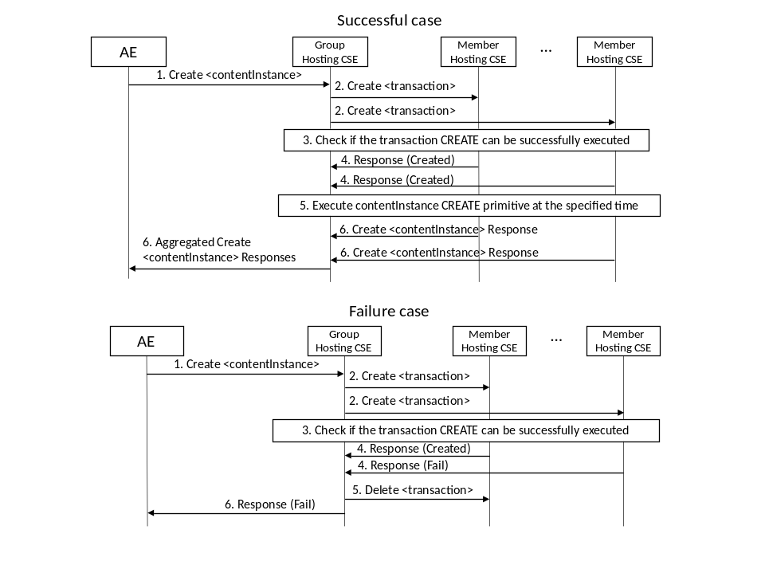
Figure 8.1.2.1-2: transactionFanOutPoint procedure
Step 1: AE sends a oneM2M primitive (e.g. CREATE <contentInstance>) to a group Hosting CSE that targets a <transactionFanOutPoint> resource. The request may contain a Result Expiration Time parameter.
Step 2: The group Hosting CSE processes the request by fanning out a corresponding <transaction> CREATE request to each of the member resources specified by the memberIDs attribute of the targeted parent <group> resource. For each <transaction> CREATE request it fans out, the group Hosting CSE will configure the primitive attribute with the original request primitive it received (e.g. CREATE <contentInstance>), the state attribute with a value of “Initial” and the executionTime attribute with value that is less than the Result Expiration Time parameter, if specified by Originator, or a value based on a local policy configured at the group Hosting CSE. The executionTime of all the fanned out <transaction> requests will be the same to guarantee the commit of the transaction is cooridinated across member Hosting CSEs. The group Hosting CSE will then wait for responses from each of the member Hosting CSEs indicating whether or not they received the <transaction> CREATE request and if it’s primitive can be successfully executed or not. A timeout will be supported by the group Hosting CSE in case responses from one or more member Hosting CSEs are not received. If the Result Expiration Time parameter is received from the Originator, the timeout should be set to enforce this parameter, otherwise, the timeout will be configured based on a local policy configured at the group Hosting CSE.
Step 3: For each member Hosting CSE that receives a <transaction> CREATE request, it checks if the primitive contained in the primitive attribute of the <transaction> can be successfully executed on the targeted member resource. This checking may include checking the access rights of the Originator, validating that the format of the primitive is correct, checking that the execution of the primitive can be performed at the specified time and any other necessary criteria that are critical to the success of executing the primitive.
Step 4 (Success): If the checking is successful, a member Hosting CSE responds back to the group Hosting CSE that it is able to create the transaction (as a child resource of the member resource). It also puts the targeted member resource into a reserved state. In the reserved state, the group Hosting CSE will refuse any other request that may interfere with the successful execution of the primitive on the targeted member resource.
Step 5: (Success): At the specified execution time, the member Hosting CSEs will individually execute their corresponding request primitive.
Step 6 (Success): The response from the execution of the request primitive will be returned to the group Hosting CSE. The group Hosting CSE will aggregate the responses from the individual members and return the results to the Originator.
Step 4 (Failure): If the checking at any member Hosting CSE fails, it responds back to the group Hosting CSE that it is unable to create the <transaction>. On receiving the failed response, the group Hosting CSE determines that the transaction cannot be committed, and thus sends a DELETE <transaction> request to each of the member Hosting CSE(s) which responded that they created the transaction. This DELETE <transaction> request will cancel the transaction. This DELETE <transaction> request will be sent before the scheduled execution time to ensure the cancellation takes place before the member Hosting CSE(s) execute the transaction.
Step 5 (Failure): The member Hosting CSE(s) which successfully created the <transaction> delete it.
Step 6 (Failure): The group Hosting CSE returns a response to the Originator informing it that the request failed indicating that it was not performed on any of the group member resources.
Optional additional steps:
Step 4 (Failure): On receiving a failed response from one or more member Hosting CSEs, the group Hosting CSE may decide if the <transaction> can be retried by sending another <transaction> CREATE request to the failed member Hosting CSE(s). This retry will be performed before the Result Expiration Time (if specified by the Originator), or before a transaction timeout based on the local policy configured at the group Hosting CSE.

8.1.3 Solution #3

8.1.3.1 Overview
Editor’s Note: To support rollback mechnism, probably locking mechniams needs to be investigated.
A CSE as a platform to applications provides transaction management service. The transaction management service consists of checking if the transactions can be performed on the targeted resources, handling transactions on targets when any of the targeted transactions cannot be performed, commit transactions after the confirmation by explicit command or timer based commnd.
As the overall scenario, an Originator creates <transactionMgmt> resource on a CSE. This resource is the transaction management configuration having individual transaction tasks targeting multiple resources. Note that oneM2M transaction is of course resource manipulation. Therefore an individual/sub transaction represented as <transaction> resource is a oneM2M request primitive.
When the <transactionMgmt> resource is created, the <transactionMgmt> resource Hosting CSE will send <transaction> create reuqest(s) to targeted resource(s). When it can be executed, the <transaction> resource will be created and that confirmation will be sent back to the <transactionMgmt> resource Hosting CSE.
Each transaction for a request primitive can be executed by the timer or explicit command. When the request transaction is successfully performed, the <transaction> resource Hosting CSE will send the result via a Notify request to the <transactionMgmt> resource Hosting CSE or to the Originator of <transactionMgmt> resource creation.
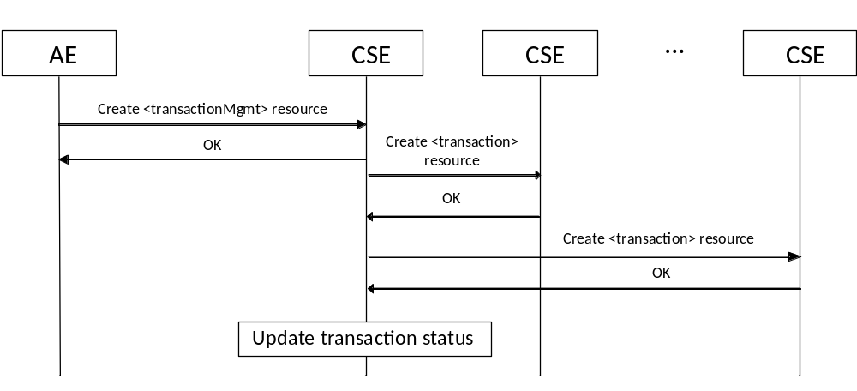
Figure 8.1.3.1-1: Transaction configuration
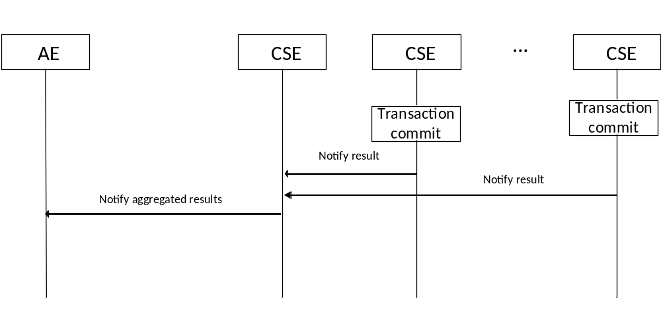
Figure 8.1.x.1-2: Transaction commit result delivery

8.1.3.2 <transactionMgmt> resource
An <transactionMgmt> resource represents one or more oneM2M primitive transaction(s) managed by the Hosting CSE to the targeted resources. An Originator creates a <transactionMgmt> resource having targets and associated request primitives. Different transaction targets may share the same primitive to be executed. When the <trasactionMgmt> resource is created, the <trasactionMgmt> resource Hosting CSE shall create <transaction> resource(s) as a child of the targeted resource(s). The target resource may be hosted by the other CSE.
The <transactionMgmt> resource Hosting CSE performs transaction management (e.g. Init, Confirmed, Commit, Commited, Abort and Aborted) instread of the Originator by handling <transaction> resources that are created by itself.
A <transactionMgmt> resource includes creator, timer, transaction status, error handling method, transaction managmenet method, primitives and associated targets. When the creator attribute is configured, the Hosting CSE shall send a Notify request for updates of the transactionStatus attribute shall be notified to the creator. The transactionTimer attribute can be set by the Orignator. If the timer is set, then this value shall be contained as the transactionTimer attribute value of the <transaction> resource creation request. The transactionStatus attribute represents the status of associated transaction tasks. When any of the <transaction> resource creation gets failed, the all transactions can be aborted depending on the uncommitableTransactionHandling attribute. When all the <transaction> resource creation were successfully created, then the Hosting CSE shall update the transactionStatus of <transaction> reseources as “Confirmed”. When the request primitives of all transaction tasks get executed successfully, the <transactionMgmt> resource can be automatically deleted depending on the transactionMgmtHandling attribute. The requestPrimitives attribute contains primitive messages with associated target resources. Also, the resultAggregation attribute is configured as “Aggregate”, the Hosting CSE shall include transactionInitiator attribute of <transaction> resource create message as the same value of the creator of this <transactionMgmt> resource.
The <transactionMgmt> resource shall contain the child resources specified in table 8.1.3.2-1.
Table 8.1.3.2-1: Child resources of <transactionMgmt> resource
Child Resources of <transactionMgmt> | Child Resource Type | Multiplicity | Description
[variable] | <subscription> | 0..n | See clause 9.6.x

The <transactionMgmt> resource shall contain the attributes specified in table 8.1.3.2-2.
Table 8.1.x3.2-2: Attributes of <transactionMgmt> resource
Attributes of  <transactionMgmt> | Multiplicity | RW/  RO/  WO | Description
resourceType | 1 | RO | See clause 9.6.1.3[i.2]
resourceID | 1 | RO | See clause 9.6.1.3[i.2].
resourceName | 1 | WO | See clause 9.6.1.3[i.2]
expirationTime | 1 | WO | See clause 9.6.1.3[i.2] The value of the expirationTime is chosen by the Transaction Timeout paramter associated with transaction request message.
parentID | 1 | RO | See clause 9.6.1.3[i.2]
creationTime | 1 | RO | See clause 9.6.1.3[i.2]
lastModifiedTime | 1 | RO | See clause 9.6.1.3[i.2]
accessControlPolicyIDs | 0..1 (L) | RO | See clause 9.6.1.3[i.2]
labels | 0..1 (L) | RO | See clause 9.6.1.3[i.2]
creator | 1 | WO | This indicates the creator, which is the initiator of the entire transactions, of this <transactionMgmt> resource.
transactionTimer | 0..1 | RW | If this attribute is set, then this value shall be contained in the <transaction> resource creation request(s), then used to execute individual transaction task(s).  If this is not set, then the transactions shall be committed by update of the transacctionStatus attribute of this <transactionMgmt> resource to “Commit”.
transactionStatus | 1 | RW | This attribute contains the status of associated transactions (e.g. Init, Confirmed, Commit, Commited, Abort and Aborted). Except the Hosting CSE, only the creator is allowed to update this attribute as “Commit” value to commit associated transactions.  If this value is updated as “Commit”, then the Hosting CSE shall update the transactionStatus attribute of associated <transaction> resource(s).
uncommitableTransactionHandling | 0..1 | RW | This attribute represents how to handle <transaction> resources when any of the associated transactions cannot be commited (E.g. Abort, Retry). If it is not set, the default action is “Abort”. When the Hosting CSE aborts the <transactionMgmt> resource, it shall send a notification to the creator.
transactionMgmtHandling | 0..1 | RW | This attribute represents how to handle this <transactionManagement> resource after the successful commit of the whole transactions. (E.g. Delete, Remain). If it is not set, the default action is “Delete”.
requestPrimitives | 0..n | WO | This attribute contains request primitive messages and associated target resources.
resultAggregation | 0..1 | RW | This attribute represents whether the <transactionMgmt> resource Hosting CSE aggregates the results of individual transaction execution results or not. If it is not set, the default action is “Aggregate”
Editor’s Note: when multiple targets have the same primitive, the primitive should not have To parameter. This needs to be fixed in this candidate solution.

8.1.3.3 <transaction> resource
An <transaction> resource could be a child resource of any resource, except virtual resources, which is the transaction target. A <transaction> Create request shall only be originated by a CSE that hosts associated <transactionMgmt> resource. An AE is not allowed to initiate this request.
When a CSE receives an <transaction> resource create request which targets the transaction target resource, the CSE shall check if the request can be successfully performed or now. If yes, the CSE shall create the <transaction> resource as a child of the target resource. Otherwise, the CSE shall not create the <transaction> resource.
A request primitive in a <transaction> resource shall be executed when it has the transactionTimer attribute, or by the explicit commit command. This transaction task shall only be performed when the transactionStatus attribute is “Confirmed”. The commit command is represented as the <transaction> update request that modifies the transactionStatus attribute into “Commit” value. When the transaction is successfully performed, the transactionStatus attribute shall be updated as “Commited” by the Hosting CSE.
A <transaction> delete request shall abort the transaction for the parent/target resource. A <transaction> resource deletion by other primitives (e.g. grand parent resource deletion) shall abort the transaction if commit was timer based.
When the transaction is performed, the execution result of the requestPrimitive shall be delivered in a Notify request to the <transactionMgmt> resource Hosting CSE, unless the <transaction> resource has the transactionInitiator attribute. If the transactionInitiator attribute is set, then the Notify request shall be sent to the transactionInitiator.

The <transaction> resource shall contain the child resources specified in table 8.1.3.3-1.
Table 8.1.3.3-1: Child resources of <transaction> resource
Child Resources of <transaction> | Child Resource Type | Multiplicity | Description
[variable] | <subscription> | 0..n | See clause 9.6.8[i.2]

The <transaction> resource shall contain the attributes specified in table 8.1.3.3-2.
Table 8.1.3.3-2: Attributes of <transaction> resource
Attributes of  <delivery> | Multiplicity | RW/  RO/  WO | Description
resourceType | 1 | RO | See clause 9.6.1.3[i.2]
resourceID | 1 | RO | See clause 9.6.1.3[i.2].
resourceName | 1 | WO | See clause 9.6.1.3[i.2]
expirationTime | 1 | WO | See clause 9.6.1.3[i.2] The value of the expirationTime is chosen by the Transaction Timeout paramter associated with transaction request message.
parentID | 1 | RO | See clause 9.6.1.3[i.2]
creationTime | 1 | RO | See clause 9.6.1.3[i.2]
lastModifiedTime | 1 | RO | See clause 9.6.1.3[i.2]
accessControlPolicyIDs | 0..1 (L) | RO | See clause 9.6.1.3[i.2]
labels | 0..1 (L) | RO | See clause 9.6.1.3[i.2]
creator | 1 | WO | This indicates the creator of this <transaction> resource.
transactionID | 1 | WO | This indicates the resource identifier of the associated <transactionMgmt> resource.
transactionTimer | 0..1 | RW | If this attribute is set, then the requestPrimitive of this <transaction> resource shall be executed at the indicated time.  Otherwise, the transactions shall be committed by update of the transacctionStatus attribute of this <transaction> resource to “Commit”.
transactionStatus | 1 | RW | This attribute contains the status of this transaction (e.g. Init, Confirmed, Commit, Commited).  When this resource gets created, this value is set to “Init”  Except the Hosting CSE, only the creator is allowed to update this attribute as “Commit” value to commit this transaction.
requestPrimitive | 1 | WO | This attribute contains the request primitive to be excuted on the parent resource.
transactionInitiator | 0..1 | WO | This attribute contains the entity identifier who created the associated <transactionMgmt> resource. If it is not set, the result of the excuted request as a Notify request shall be sent to the <transactionMgmt> resource Hosting CSE. Otherwise, the notification shall be sent to the transactionInitiator.

8.1.4 Solution #4

8.1.4.1 Overview
A CSE supports transaction management capabilities to assist applications with the atomic and consistent processing of oneM2M request primitives on a set of targeted resources. These transaction management capabilities include the scheduling of a transaction, locking and unlocking of resources targeted by a transaction, the atomic execution of a transaction on targeted resources, the committal of successful transaction results, and the abort and rollback of non-successful transactions.
Transaction processing support within a CSE is realized via three resources. These are the <transactionMgmt>, <transactionFanoutPoint> and <transaction> resources.
A <transactionMgmt> resource is used to initiate and manage the atomic and consistent processing of a transaction consisting of multiple oneM2M request primitives.
A <transactionFanOutPoint> is a virtual child resource of a <group> resource. This resource is used to initiate and manage the processing of a transaction consisting of a single oneM2M request primitive that is fanned out to the individual member resources of a group and executed in an atomic and consistent manner.
A <transaction> resource is used to manage the processing of each individual oneM2M request primitive associated with a transaction that is initiated via a <transactionMgmt> or <transactionFanoutPoint> resource.
An Originator may initiate a transaction request by either creating a <transactionMgmt> resource or targeting a oneM2M request primitive towards a <transactionFanoutPoint> resource. When receiving the transaction request, the <transactionMgmt> or <transactionFanoutPoint> Hosting CSE processes it by creating a <transaction> child resource under each resource targeted by the transaction. Each <transaction> Hosting CSE, in coordination with <transactionMgmt> or <transactionFanoutPoint> Hosting CSE, processes the oneM2M primitive associated with its <transaction> resource. During this processing, a <transaction> Hosting CSE keeps the <transactionMgmt> or <transactionFanoutPoint> Hosting CSE updated of any changes in the state of the transaction. Likewise the <transactionMgmt> or <transactionFanoutPoint> Hosting CSE controls each of the <transaction> Hosting CSEs to ensure that all the oneM2M request primitives associated with the transaction are processed in an atomic and consistent manner (i.e. either all are successfully executed or none of them are executed). The <transactionMgmt> or <transactionFanoutPoint> Hosting CSE also interacts with the Originator of the transaction to provide it with the results of the transaction.

8.1.4.2 <transactionMgmt> resource
A <transactionMgmt> resource defines a transaction consisting of oneM2M request primitives targeting multiple resources that require excution in an atomic and consistent manner. The targeted resources may be hosted by one or more CSEs. When an Originator creates a <transactionMgmt> resource, the <trasactionMgmt> Hosting CSE will create corresponding child <transaction> resources for each of the oneM2M request primitives under their respective targeted resources.
The transactionState attribute is used by the <transactionMgmt> Hosting CSE to reflect the current state of the transaction.
The transactionControl attribute is used by the <transactionMgmt> resource creator or Hosting CSE to manage the atomic execution of transaction via controlling the state of the transaction.
The transactionExecutionTime attribute is used by the <transactionMgmt> Hosting CSE to schedule the execution of the transaction. The <transactionMgmt> Hosting CSE uses this time value to schedule when it creates the corresponding <transcation> resources.
The transactionExpirationTime attribute is used by the <transactionMgmt> Hosting CSE to manage the expiration of the transcation. If the transcation is not successfully committed before this time, the Hosting CSE will abort the transcation.
The transactionMode attribute is used by the <transactionMgmt> Hosting CSE to determine whether it is responsible for managing the state of the transactionContol attribute and in turn the atomic execution of the transaction on behalf of the creator or whether the creator wishes to manage the state of the transactionContol attribute itself. When transactionMode is set to " CREATOR_CONTROLLED " then the creator is responsible for controlling the state of transactionContol. When transactionMode is set to " CSE_CONTROLLED " then the <transactionMgmt> Hosting CSE is responsible for controlling the state of transactionContol.
When the transactionControl attribute of the <transactionMgmt> resource is updated, the <transactionMgmt> Hosting CSE will make corresponding updates to the transactionControl attributes of all the <transaction> resources affiliated with the transaction. These updates will trigger the <transaction> Hosting CSE(s) to take corresponding action to lock the targeted resource, execute the specified primitive on the locked resource, commit the executed results or abort the transaction. As a result, the atomic execution of the transaction can be explicitly controlled. The decision to update the transactionControl attribute of the <transactionMgmt> resource will be based on the collective transactionState of the individual <transaction> resources. When consistent state is detected (E.g. all <transasction> resources indicate their transactionState is "LOCKED"), then a decision can be made to update the transaction state (e.g. update <transactionMgmt> transactionControl to "EXECUTE"). When inconsistent state is detected (e.g. one <transaction> resource indicates a transactionState of "ERROR"), then a decision can be made to abort the transaction (e.g. update the <transactionMgmt> transactionControl to "ABORT"). To facilitate the gathering of this collective transactionState, each <transaction> Hosting CSE will share transactionState information with the <transactionMgmt> Hosting CSE. This transactionState will be shared in the <transaction> create and update responses that a <transaction> Hosting CSE returns to the <transactionMgmt> Hosting CSE. The <transactionMgmt> Hosting CSE will in turn update the transactionState attribute of the <transactionMgmt> resource to reflect the collective state of the <transction> resources. The creator of <transactionMgmt> resource may subscribe to the transactionState attribute of the <transactionMgmt> resource to receive notifications for any state changes.
Table 8.1.4.2-1 defines the valid transactionControl values permitted in an update request to a <transaction> resource based on the current value of the <transcation> resources’s transactionState. A <transaction> Hosting CSE will only allow an update to transcationControl to complete successfully for the combinations listed.

Table 8.1.4.2-1: Valid <transactionMgmt> transactionControl update values
Current transactionState | Valid transactionControl update values
INITIAL | LOCK
LOCKED | EXECUTE, ABORT
EXECUTED | COMMIT, ABORT
ERROR | ABORT
COMMITTED | LOCK
ABORTED | LOCK

The <transactionMgmt> Hosting CSE supports transaction expiration functionality to detect when the processing of transactions by one or more <transaction> Hosting CSEs exceeds the transactionExpirationTime. If this occurs, the <transactionMgmt> Hosting CSE will abort the transaction by updating the transactionState attribute of each <transaction> resource to “ABORT”.

The <transactionMgmt> resource supports the child resources specified in table 8.1.4.2-2.

Table 8.1.4.2-2: Child resources of <transactionMgmt> resource
Child Resources of <transactionMgmt> | Child Resource Type | Multiplicity | Description
[variable] | <subscription> | 0..n | See clause 9.6.x [i.2]

The <transactionMgmt> resource supports the attributes specified in table 8.1.4.2-3.

Table 8.1.4.2-3: Attributes of <transactionMgmt> resource
Attributes of  <transactionMgmt> | Multiplicity | RW/  RO/  WO | Description
resourceType | 1 | RO | See clause 9.6.1.3[i.2]
resourceID | 1 | RO | See clause 9.6.1.3[i.2].
resourceName | 1 | WO | See clause 9.6.1.3[i.2]
expirationTime | 1 | WO | See clause 9.6.1.3[i.2]
parentID | 1 | RO | See clause 9.6.1.3[i.2]
creationTime | 1 | RO | See clause 9.6.1.3[i.2]
lastModifiedTime | 1 | RO | See clause 9.6.1.3[i.2]
accessControlPolicyIDs | 0..1 (L) | RW | See clause 9.6.1.3[i.2]
labels | 0..1 (L) | RW | See clause 9.6.1.3[i.2]
creator | 1 | RO | This attribute is configured with the identifier of the entity that originated the request to create this <transactionMgmt> resource.
transactionExecutionTime | 0..1 | WO | This attribute contains a timestamp of when the <transactionMgmt> Hosting CSE will execute the transaction. When this time elapses, the <transactionMgmt> Hosting CSE will generate <transaction> create requests for each of the specified requestPrimitives. If this attribute is not set, the transaction will be executed immediately.
transactionExpirationTime | 0..1 | WO | This attribute contains a timestamp of when the execution of the transaction is set to expire. The <transactionMgmt> Hosting CSE uses this value to configure the expirationTime attribute of the <transaction> resources it creates. If a transaction fails to complete before this time elapses, the <transactionMgmt> Hosting CSE will abort the transaction.
transactionMode | 0..1 | WO | This attribute is used by the Hosting CSE to determine whether it is responsible for controlling the execution of the transaction (via the transcationControl attribute) or whether the creator is responsible for controlling it.  The allowed values are:  - CSE_CONTROLLED (Default)  - CREATOR_CONTROLLED
transactionControl | 0..1 | RW | This attribute is used to control the state of the transaction.  The allowed values are:  - INITIAL (default)  - LOCK  - EXECUTE  - COMMIT  - ABORT  If the transactionMode is set to “CSE_CONTROLLED”, then only the <transactionMgmt> Hosting CSE is allowed to update this attribute.  If the transactionMode is set to “CREATOR_CONTROLLED”, then only the creator is allowed to update this attribute.  This attribute must either not be present in a <transactionMgmt> create request or have a value of “INITIAL”.
transactionState | 1 | RO | This attribute contains the current state of the transaction. Only the <transactionMgmt> Hosting CSE is allowed to update this attribute. It calculates the value of this attribute based on collective transactionState of the individual <transaction> resources associated with this <transactionMgmt> resource.  The allowed values are:  - INITIAL  - LOCKED  - EXECUTED  - COMMITTED  - ERROR  - ABORTED  To update this attribute to a new state all of the transactionState attributes of the individual <transaction> resources must be consistent and reflect the value of the new state. The exception is updating this attribute to “ERROR”. If any of the transactionState attributes of the individual <transaction> resources have a value of “ERROR”, then the <transactionMgmt> Hosting CSE updates transactionState of this <transactionMgmt> resource to “ERROR”. Before doing so however, the <transactionMgmt> Hosting CSE checks if the transactonMaxRetries attribute is configured with a non-zero value and if so whether the retry limit has been exhausted. If not exhausted, the <transactionMgmt> Hosting CSE attempts to retry the transaction. If the transactonMaxRetries attribute is configured with zero value or the retry limit is exhausted, then this attribute is set to “ERROR”.  A creator may subscribe to this attribute to receive notifications of changes to transactionState.
transactionMaxRetries | 0..1 | RW | If set, this attribute is used by the <transactionMgmt> Hosting CSE to determine the max number of times it may attempt to retry a transaction when detecting an “ERROR” transactionState from one or more <transaction> Hosting CSEs.  If not set or if the max number of retries is exhausted, and the <transactionMgmt> Hosting CSE detects an “ERROR” transactionState from one or more <transaction> Hosting CSEs, then the transactionState of the <transactionMgmt> resource is updated to “ERROR”.
transactionMgmtHandling | 0..1 | RW | This attribute is used by the <transactionMgmt> Hosting CSE to determine whether to persist or delete the <transactionManagement> resource after its completion (i.e. transactionState is set to “COMMITTED” or “ABORTED”).  The allowed values are:  - DELETE (default)  - PERSIST  If set to “PERSIST” the <transactionMgmt> resource will be deleted when the expirationTime elapses.
requestPrimitives | 1(L) | WO | This attribute contains an aggregated list of oneM2M request primitives associated with this transaction. When processing this transaction, the <transactionMgmt> Hosting CSE creates a corresponding <transaction> resource for each oneM2M request primitive in this list. Each <transaction> resource is created as a child resource under the resource targeted by its respective request primitive.
responsePrimitives | 1(L) | RO | This attribute contains an aggregated list of oneM2M response primitives associated with this transaction. This attribute is updated by the <transactionMgmt> Hosting CSE and includes the individual responsePrimitive attributes received from the <transaction> Hosting CSE(s).  The creator may subscribe to this attribute to receive notifications each time this attribute is updated with new response primitive(s).

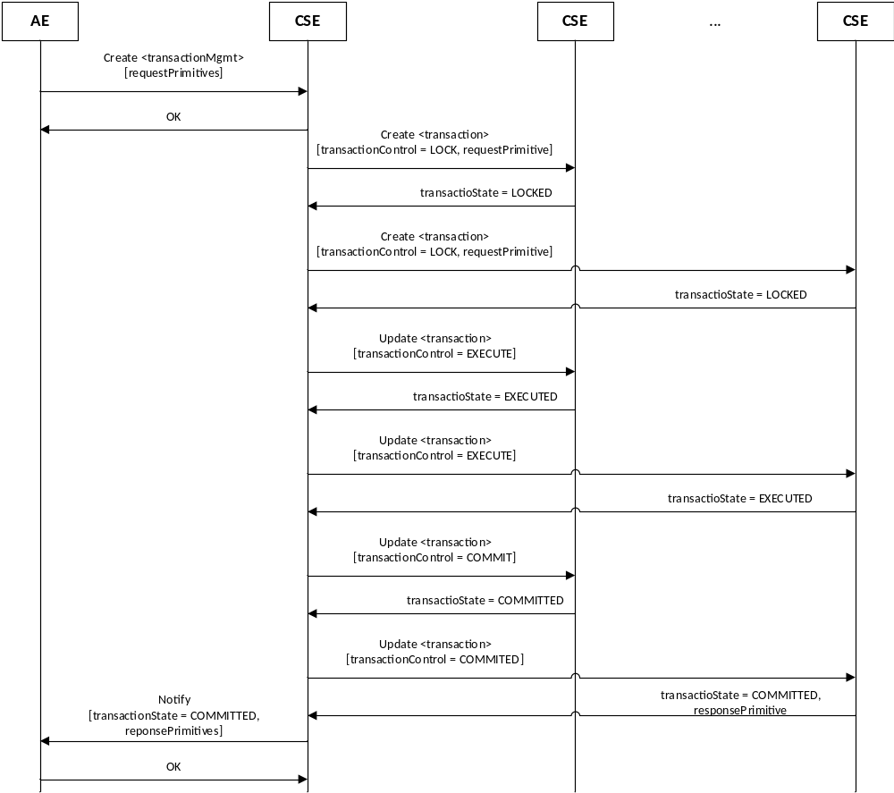

Figure 8.1.4.2-1: <transactionMgmt> - Successful Case

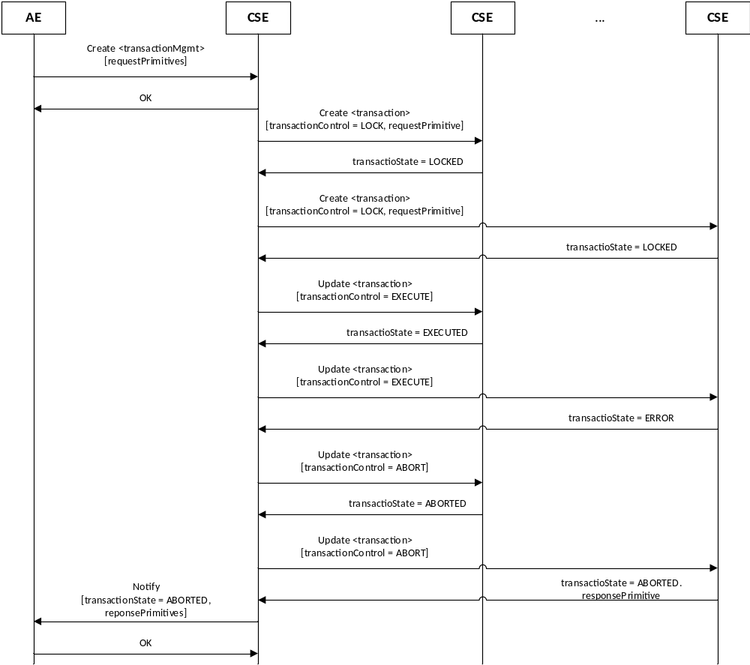

Figure 8.1.4.2-2: <transactionMgmt> - Failure Case

8.1.4.3 <transactionFanOutPoint> resource
The <transactionFanOutPoint> resource is a virtual resource hence it does not have a representation. It is the child resource of a <group> resource. Whenever a oneM2M request primitive is sent to the <transactionFanOutPoint> resource, the group Hosting CSE processes the request by fanning out a corresponding <transaction> create request to each of the members specified by the memberIDs attribute of the parent <group> resource. For each <transaction> create request it fans out to a member, the group Hosting CSE will configure the requestPrimitive attribute with the original request primitive received from the Originator. The group Hosting CSE will also configure the transactionState attribute of each <transaction> resource to “LOCK” to request that the member Hosting CSEs attempt to lock the targeted resource.
If all the member Hosting CSEs are able to successfully lock the targeted resources, the group Hosting CSE will continue updating the transactionControl attribute of each <transaction> resource in a consistent manner to ensure the atomic and consistent execution of the fanned out requests (i.e. all the fanned out transactions either complete successfully or all are aborted). The updates to transactionControl will trigger the member Hosting CSEs to take corresponding action to execute the specified primitive on the locked resource, commit the executed results or abort the transaction.
The group Hosting CSE’s decision to update the transactionControl attribute of each <transaction> resource is based on the collective transactionState of the individual <transaction> resources. When consistent state is detected (E.g. all member’s <transasction> resources indicate their transactionState is "LOCKED"), then a decision can be made to update the transaction state (e.g. update transactionControl to "EXECUTE" for all members). When inconsistent state is detected (e.g. one member’s <transaction> resource indicates a transactionState of "ERROR"), then a decision can be made to retry or abort the transaction (e.g. update the transactionControl to "ABORT" for all members). To facilitate the gathering of this collective transactionState, each member Hosting CSE will share transactionState information with the group Hosting CSE. This transactionState will be shared in the <transaction> create and update responses that a member Hosting CSE returns to the group Hosting CSE. The individual responses from each request primitive executed on a member will also be returned to the group Hosting CSE. The group Hosting CSE will then aggregate the responses and return the results to the Originator.
The group Hosting CSE supports transaction expiration functionality to detect when the processing of transactions by one or more member Hosting CSEs exceeds a configured time limit. If this occurs, the group Hosting CSE will abort the transaction by updating the transactionState attribute of each <transaction> resource to “ABORT”.
The following diagram shows the flow for how a group Hosting CSE handles the atomic processing of a request that targets a <transactionFanOutPoint> resource.
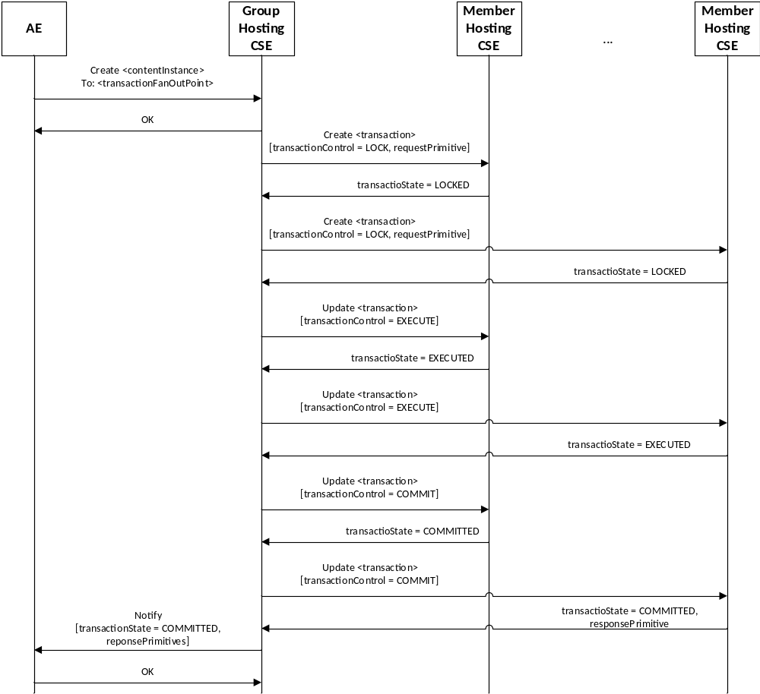

Figure 8.1.4.3-1: <transactionFanOutPoint> - Successful Case

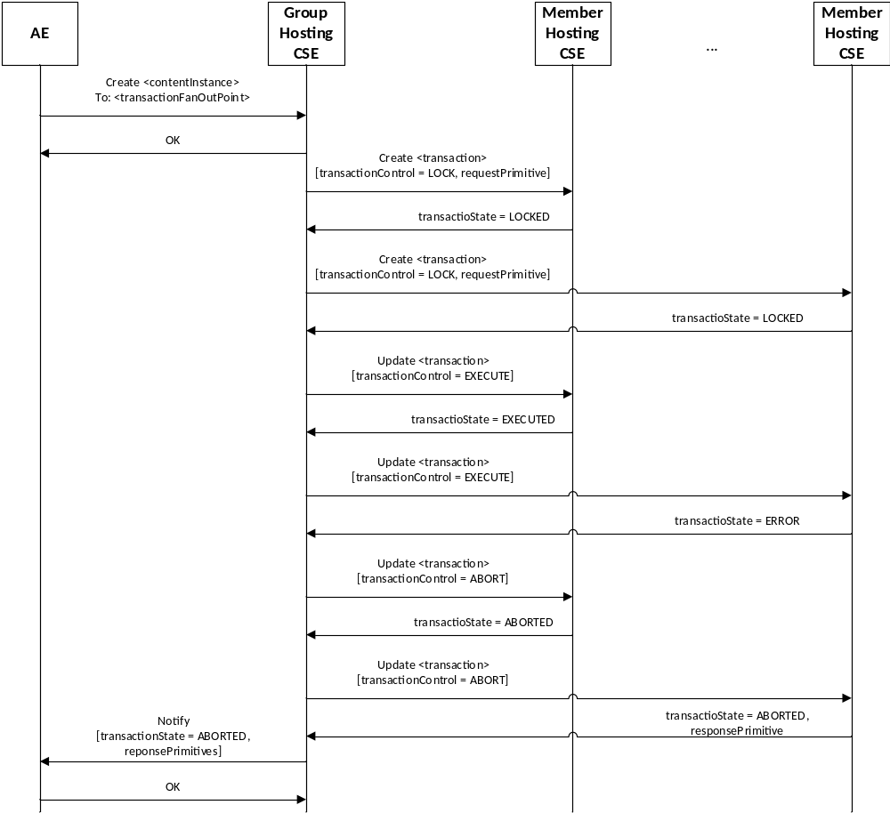

Figure 8.1.4.3-2: <transactionFanOutPoint> - Failure Case

8.1.4.4 <transaction> resource
With the exception of virtual resources (e.g. latest, oldest, etc) a <transaction> resource may be created as a child resource of any resource targeted by a transaction. A <transaction> create request will only be originated by a CSE that hosts an associated <transactionMgmt> or <transactionFanOutPoint> resource. An AE is not allowed to create a <transaction> resource.
When a CSE receives a request to create a new <transaction> resource, the CSE will first check if the targeted resource is already locked. To perform this check, the CSE will check whether any other <transaction> resources exist for the targeted resource. If yes, the CSE will check the transactionState of these other <transaction> resource(s). If no other <transcation> resources exist or the transactionState of the existing <transaction> resources is “COMMITTED” or “ABORTED”, the CSE will consider the targeted resource unlocked, otherwise it will consider it locked. If the targeted resource is locked, the CSE may return an error to the Originator of the <transaction> create request. Alternatively, the CSE may buffer requests that target the resource until the resource is unlocked. Note, the details of how a CSE manages this buffering are currently outside the scope of the specification. If a CSE does support buffering for locked resources, then the CSE should also support a timeout mechanism to detect the case where a lock is not released in a timely manner.
Once the <transaction> Hosting CSE obtains a lock for the targeted resource or determines that a lock cannot be obtained, it responds to the Originator of the <transaction> create request. In this response, the transactionState is included. If the lock is obtained, then the transactionState will have a value of “LOCKED”. If the lock cannot be obtained, then the transactionState will have a value of “ERROR”.
When a <transaction> Hosting CSE receives a request to update the transactionControl attribute of an existing <transaction> resource, the CSE will first compare the current value of the transactionState and transactionControl attributes to ensure they are consistent (e.g. if transactionControl has a value of “LOCK” then transactionState should have a value of “LOCKED”). This check ensures that the <transaction> Hosting CSE is not already in the process of changing the state of the transaction. In addition, the <transaction> Hosting CSE will also compare the value of transactionControl specified in the <transaction> update request with the current value of transactionControl in the <transaction> resource to ensure the value specified in the update request is a legal next state (e.g. if transactionState has a value of “LOCKED” then valid transactionControl values are “EXECUTE or “ABORT”). If any of these checks fail, the <transaction> Hosting CSE will return an error. If these checks pass, the <transaction> Hosting CSE will perform the update to transactionControl and in turn perform the corresponding actions associated with transitioning the transaction into this new state.

Table 8.1.4.4-1: Valid <transaction> transactionContol values
Current transactionState | Valid transactionControl update values
LOCKED | EXECUTE, ABORT

EXECUTED | COMMIT, ABORT
ERROR | ABORT
COMMITTED | LOCK
ABORTED | LOCK

If transactionControl is updated to “EXECUTE”, then the <transaction> Hosting CSE will perform the request specified in the requestPrimitive attribute and update the responsePrimitive attribute with the results. If the execution of the primitive is successful the <transaction> Hosting CSE will update the transactionState attribute to “EXECUTED”. Otherwise, if the execution of the primitive is not successful the <transaction> Hosting CSE will update the transactionState attribute to “ERROR”.
If transactionControl is updated to “COMMIT”, then the <transaction> Hosting CSE will make the results of the requestPrimitive persistent and visible by updating and the transactionState attribute to “COMMITTED” which effectively releases the lock on the targeted resource.
If transactionControl is updated to “ABORT”, the <transaction> Hosting CSE will roll back the transaction by returning the state of the targeted resource to the same state the resource was in before the processing of this transaction began. It will also update the transactionState attribute to “ABORTED” which effectively releases the lock on the targeted resource.
Once the <transaction> Hosting CSE completes processing any actions associated with updating the transactionControl attribute and changing the state of transaction, it will return a response back to the Originator of the <transaction> update request. In this response, the attributes of the <transaction> resource will be included to allow the Originator to check the transactionState and aggregate the responsePrimitive.
If a <transcation> delete request is received, the <transaction> Hosting CSE will check the transactionState. If the <transaction> resource has a transactionState of “INITIAL”, “LOCKED”, “EXECUTED” or “ERROR”, the <transaction> Hosting CSE will roll back the transaction by returning the state of the targeted resource to the same state the resource was in before the processing of this transaction began. It will also set the transactionState attribute to “ABORTED” in the <transaction> delete response.
If a <transcation> resource is deleted by a delete request that targets the parent or ancestor of the <transaction> resource, the <transaction> Hosting CSE will check the transactionState. If the <transaction> resource has a transactionState of “INITIAL”, “LOCKED”, “EXECUTED” or “ERROR”, the <transaction> Hosting CSE will roll back the transaction by returning the state of the targeted resource to the same state the resource was in before the processing of this transaction began.

The <transaction> resource supports the child resources specified in table 8.1.4.4-2.

Table 8.1.4.4-2: Child resources of <transaction> resource
Child Resources of <transaction> | Child Resource Type | Multiplicity | Description
[variable] | <subscription> | 0..n | See clause 9.6.8[i.2]

The <transaction> resource supports the attributes specified in table 8.1.4.4-2.

Table 8.1.4.4-2: Attributes of <transaction> resource
Attributes of  <delivery> | Multiplicity | RW/  RO/  WO | Description
resourceType | 1 | RO | See clause 9.6.1.3[i.2]
resourceID | 1 | RO | See clause 9.6.1.3[i.2].
resourceName | 1 | WO | See clause 9.6.1.3[i.2]
expirationTime | 1 | WO | See clause 9.6.1.3[i.2]  The value of the expirationTime serves as the expiration time of the transaction.
parentID | 1 | RO | See clause 9.6.1.3[i.2]
creationTime | 1 | RO | See clause 9.6.1.3[i.2]
lastModifiedTime | 1 | RO | See clause 9.6.1.3[i.2]
accessControlPolicyIDs | 0..1 (L) | RO | See clause 9.6.1.3[i.2]
labels | 0..1 (L) | RO | See clause 9.6.1.3[i.2]
creator | 1 | RO | This attribute is configured with the CSE-ID of the <transactionMgmt> or <transactionFanOutPoint> Hosting CSE that created this <transaction> resource.
transactionID | 1 | WO | This attribute is configured with the identifier of the transaction.  When the <transaction> resource is created by a <transactionMgmt> Hosting CSE, this attribute is configured with the resource identifier of the <transactionMgmt> resource.  When the <transaction> resource is created by a <transactionFanOutPoint> Hosting CSE, this attribute is configured with a unique identifier generated by the <transactionFanOutPoint> Hosting CSE.
transactionControl | 1 | RW | This attribute is used to configure or change the state of the transaction.  The allowed values are:  - LOCK  - EXECUTE  - COMMIT  - ABORT  Only the creator of this <transaction> resource is allowed to update this attribute.
transactionState | 1 | RO | This attribute contains the current state of the transaction. Only the Hosting CSE of this <transaction> resource is allowed to update this attribute.  The allowed values are:  - LOCKED  - EXECUTED  - COMMITTED  - ERROR  - ABORTED
requestPrimitive | 1 | WO | This attribute contains the request primitive to be excuted on the parent of this <transaction> resource.
responsePrimitive | 1 | RO | This attribute contains the oneM2M response primitive associated with this transaction. This attribute is updated by the <transaction> Hosting CSE after it executes the requestPrimitive on the parent resource.

8.2 Re-usable service layer context

8.3 Support for Realtime Multimedia Sessions
Multimedia sessions refer to a session where two peers communicating with the oneM2M system, typically, two AEs, exchange media that has to be streamed between them and that requires specific Quality of Service (QoS). The streamed media will not traverse the oneM2M control nodes but will go directly between the two peers. The oneM2M system role is twofold:
- To facilitate the exchange of multimedia session descriptors (e.g. SDP descriptors) between two AEs for the purposes of multimedia session management (e.g. discovery, establishment, update and teardown).
- When applicable, to ensure that the underlying network nodes that the streamed media traverse shall be provisioned with the proper QoS for the session. The required QoS for the streamed media shall be negotiated between the two AEs through the oneM2M system.
Negotiation between AEs requiring a multimedia session shall be based on SDP as defined in [i.3]. Two modes for negotiation shall be supported by oneM2M:
- In the first mode, the originating AE provides only one offer that the target AE can reject or accept as is.
- In the second mode, the originating AE provides multiple offers and the target AE can reject all offers or accept one and return the accepted offer in the response.
A multimedia session has typically 3 procedures associated with it: session establishment; session update, and session termination.
To modify (UPDATE) an ongoing session, the session shall be put on hold first, and after successful updating, it shall be resumed. Note that SDP as defined [i.3] specifies all these aspects.

8.3.1 Roles of M2M Nodes to support multimedia sessions
There are several potential types of deployment scenarios involving multimedia sessions. Some examples are as follows:
- Scenario 1 where two ADN-AEs and an IN-CSE are involved
- Scenario 2 where two ADN-AEs, an MN-CSE and an IN-CSE are involved
- Scenario 3 where two ADN-AEs, two MN-CSEs, and an IN-CSE are involved
For scenario 1, both ADN-AEs are registered to a common IN-CSE. The IN-CSE shall be used by the AEs to facilitate the exchange of multimedia session descriptors (e.g. SDP descriptors) between the two AEs for the purposes of multimedia session management (e.g. discovery, establishment, update and teardown). The IN-CSE may also interwork with the underlying network to ensure that the underlying network is provisioned with the proper QoS for the session based on the QoS negotiated between the two AEs through the oneM2M system. For example, the underlying network may be a 3GPP Core Network and via the Mcn reference point the IN-CSE can interwork with the PCRF function in the 3GPP Network to ensure the communication session between the ADN-AEs is provisioned with the proper QoS level. The details of how the IN-CSE interworks with the 3GPP Core Network are out of scope for this document however these details are the focus of another active oneM2M work item (WI-0037 3GPP Release 13 Interworking).
The figure below depicts scenario 1 using 3GPP as an underlying network.
ADN-AE 2
-
Multimedia
Session
Control

Session
Announcement,
Discovery,
Invitation,
Negotiatoin

IN-CSE
Mca
Internal
Mca
Underlying Network
Mcn
ADN-AE 1
Multimedia
Session
Control

Session
Announcement,
Discovery,
Invitation,
Negotiatoin

Internal
Multimedia
Session
Streamed
Data
Multimedia
Session
Streamed
Data
PCRF
Gx/Gac
Packet
Core
network
Nodes
E.g. 3GPP Core Network
Figure 8.3.1-1: Two AEs in a real time multimedia session established via an IN-CSE

For scenario 2, ADN-AE 1 is registered to the MN-CSE, the MN-CSE is registered to the IN-CSE, and the ADN-AE 2 is registered to the IN-CSE. Both the MN-CSE and IN-CSE shall be used by the AEs to facilitate the exchange of multimedia session descriptors (e.g. SDP descriptors) between the two AEs for the purposes of multimedia session management (e.g. discovery, establishment, update and teardown). Similar to scenario 1, the IN-CSE may also interwork with the underlying transport network to ensure that the underlying network is provisioned with the proper QoS for the session based on the QoS negotiated between the two AEs through the oneM2M system.
Note, if the registrar CSE of the AE that is the target of a multimedia session is not the IN-CSE, then it is the responsibility of this CSE to create the necessary multimedia session resource in the IN-CSE before an offer can be accepted by the target AE and before a response is returned to the multimedia session originator.
Note, if a multimedia session requires updating, regardless of which AE initiated the update, if the registrar CSE of the AE that is the target of a multimedia session is not the IN-CSE, then it is the responsibility of this CSE to also update the necessary multimedia session resource in the IN-CSE before the update can be completed and before a response is returned to the multimedia session originator.

IN-AE
Multimedia
Session
Control

Session
Announcement,
Discovery,
Invitation,
Negotiatoin

IN-CSE
Mca
Internal
Mca
Underlying Transport
Network
Mcn
ADN-AE
Multimedia
Session
Control

Session
Announcement,
Discovery,
Invitation,
Negotiatoin

Internal
Multimedia
Session
Streamed
Data
Multimedia
Session
Streamed
Data
PCRF
Gx/Gac
Packet
Core
network
Nodes
E.g. 3GPP Core Network
MN-CSE
Mcc
Figure 8.3.1-2: Two AEs in a real time multimedia session established via an IN-CSE and MN-CSE

For scenario 3, ADN-AE 1 is registered to MN-CSE 1 which is registered to the IN-CSE. Similarly, ADN-AE 2 is registered to MN-CSE 2 which is registered to the IN-CSE. Both MN-CSEs and IN-CSE shall be used by the AEs to facilitate the exchange of multimedia session descriptors (e.g. SDP descriptors) between the two AEs for the purposes of multimedia session management (e.g. discovery, establishment, update and teardown). Similar to scenario 1, the IN-CSE may also interwork with the underlying transport network to ensure that the underlying network is provisioned with the proper QoS for the session based on the QoS negotiated between the two AEs through the oneM2M system.
Note, if the registrar CSE of an AE that is the target of a multimedia session is not the IN-CSE, then it is the responsibility of this CSE to create the necessary multimedia session resource in the IN-CSE before an offer can be accepted by the target AE and before a response is returned to the multimedia session originator.
Note, if a multimedia session requires updating, regardless of which AE initiated the update, if the registrar CSE of the AE that is the target of a multimedia session is not the IN-CSE, then it is the responsibility of this CSE to also update the necessary multimedia session resource in the IN-CSE before the update can be completed and before a response is returned to the multimedia session originator.

ADN-AE 2
Multimedia
Session
Control

Session
Announcement,
Discovery,
Invitation,
Negotiatoin

IN-CSE
Mca
Internal
Mca
Underlying Transport
Network
Mcn
ADN-AE 1
Multimedia
Session
Control

Session
Announcement,
Discovery,
Invitation,
Negotiatoin

Internal
Multimedia
Session
Streamed
Data
Multimedia
Session
Streamed
Data
PCRF
Gx/Gac
Packet
Core
network
Nodes
E.g. 3GPP Core Network
MN-CSE
1
Mcc
MN-CSE
2
Mcc
Figure 8.3.1-3: Two AEs in a real time multimedia session established via an IN-CSE and two MN-CSEs

8.3.2 Real time Multimedia Session examples
This section provides some examples for the establishment/update of a multimedia session to clarify the usage of applicable resources and the service description depicted above

8.3.2.1 Example 1 - Establishing Multimedia Session between ADN-AEs via IN-CSE
This example is based on the scenario 1 captured is Figure 8.3.1-1. The corresponding call flow is captured in Figure 8.3.2.1-1. In this example, ADN-AE 1 is registered with the IN-CSE and wishes to establish a multimedia session with a target ADN-AE 2 that is also registered to the IN-CSE. In this scenario the IN-CSE may also be involved to ensure that the wide area network resources are configured with the proper QoS for the negotiated session.

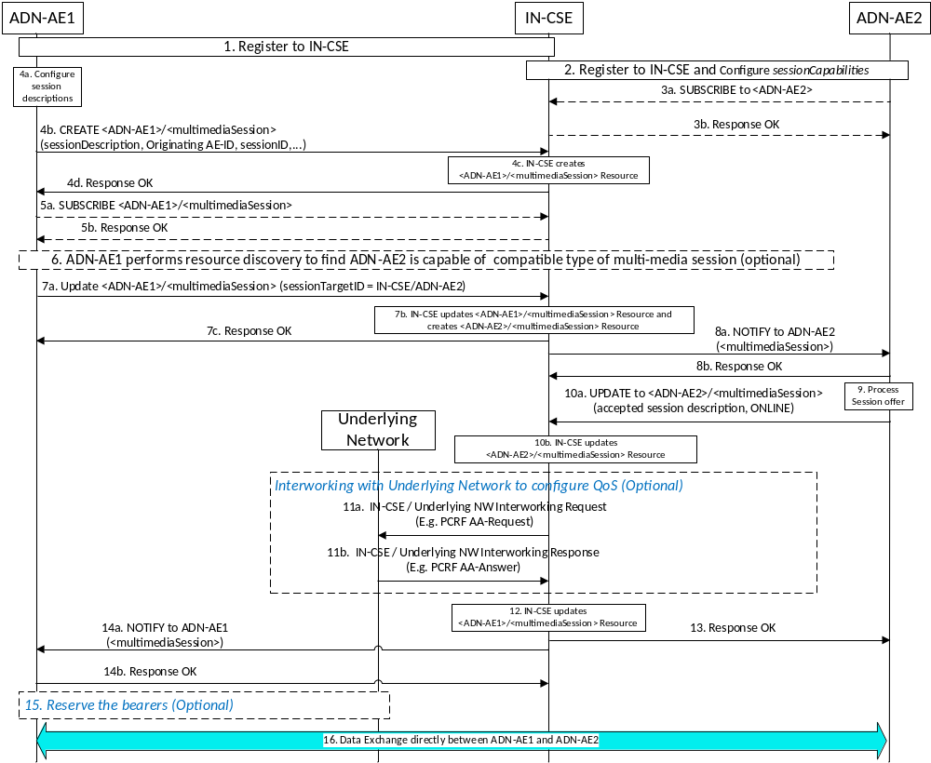
Figure 8.3.2.1-1: Establishing Real time multimedia session between ADN-AEs via IN-CSE
The following is a brief description of the steps in the above call flow:
- In steps 1 and 2, the originating ADN-AE 1 and target ADN-AE 2 register to the IN-CSE by creating resources of type <AE>. ADN-AE 2 also configures the sessionCapabilities attribute of its <AE> resource to advertise its multimedia session capabilities such that other AEs can discover this information.
- In steps 3a and 3b, ADN-AE 2 subscribes to its < ADN-AE2> resource hosted in the IN-CSE to receive notifications of multimedia session offers from originator AEs. Note, these steps may be optional if CSE supports sending notification to AE without a subscription when <multimediaSession> resource is created/update/deleted.
- In steps 4a-d, the originating ADN-AE 1 creates a child resource of type <multimediaSession> under its < ADN-AE1> resource hosted in the IN-CSE. This resource is configured with the session descriptions that ADN-AE 1 wishes to offer to target AEs.
- In steps 5a and 5b, ADN-AE 1 subscribes to its <multimediaSession> resource hosted in the IN-CSE to receive notifications of multimedia session updates from target AEs . Note, these steps may be optional if CSE supports sending notification to AE without a subscription when <multimediaSession> resource is created/update/deleted.
- In step 6, ADN-AE 1 performs a resource discovery operation to query and find potential target AEs having desired multimedia sessionCapabilities that are compatible with its own. In this example, the response returns a URI of <ADN-AE2>.
- In steps 7a-c, ADN-AE 1 sends a multimedia session offer to ADN-AE 2. This is accomplished by ADN-AE 1 updating the sessionTargetID attribute of the <ADN-AE1>/<multimediaSession> resource with the resourceID of <ADN-AE2>. The IN-CSE processes the update and as a result triggers the creation of a <ADN-AE2>/<multimediaSession> resource as a result.
- In steps 8a and 8b, the IN-CSE sends a notification to ADN-AE 2 containing the representation of the newly created <ADN-AE2>/<multimediaSession> resource.
- In step 9, ADN-AE 2 processes the notification, detects it is a multimedia session offer, examines the offered session descriptions and selects a session description that it wishes to accept.
- In steps 10a and 10b, ADN-AE 2 updates the <ADN-AE2>/<multimediaSession> resource based on the incoming offer and the session description it wishes to accept. It also changes the session state to ONLINE.
- In steps 11a and 11b, the IN-CSE optionally interfaces with the underlying network (in this example the Rx reference point of the PCRF of a 3GPP LTE network) to configure the proper QoS for the corresponding multimedia session.
- In step 12, the IN-CSE updates the <ADN-AE1>/<multimediaSession> resource with the accepted offer.
- In steps 13, the IN-CSE returns a response to ADN-AE 2 indicating that the update was successful.
- In steps 14a and b the IN-CSE sends a notification to ADN-AE 1 indicating the session description that the target has agreed upon and changes the session state to ONLINE.
- In step 15, the originating ADN-AE 1 may need to reserve access bearers. This is optional.
- In step 16, ADN-AE 1 and ADN-AE 2 exchange media over the established multimedia session.

8.3.2.2 Example 2 - Establishing Multimedia Session between ADN-AEs via MN-CSEs and IN-CSE
This example is based on the scenario 3 that is captured in Figure 8.3.1-2. The corresponding call flow is captured in Figure 8.3.2.1-2. In this example, ADN-AE #1 is registered with MN-CSE #1 and wishes to establish a multimedia session with a target ADN-AE #2 that is registered to IN-CSE. In this scenario the IN-CSE may also be involved to ensure that the wide area network resources are configured with the proper QoS for the negotiated session.
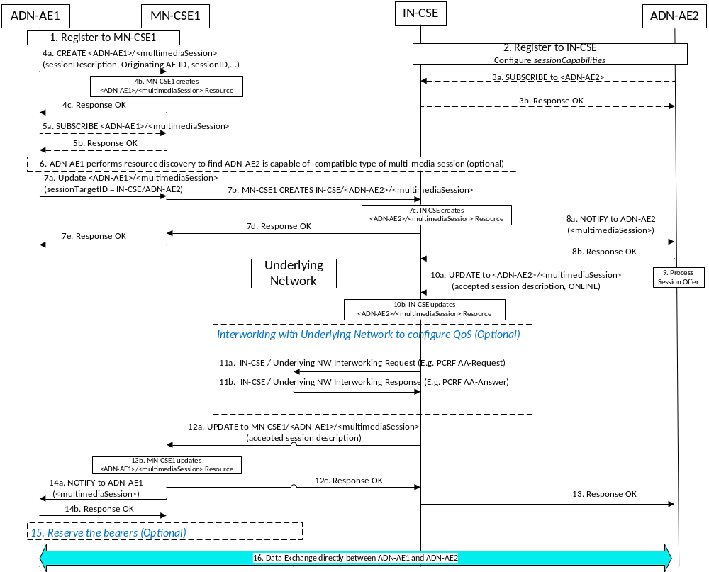
Figure 8.3.2.1-2: Establishing Real time multi-media session between ADN-AEs via MN-CSEs/IN-CSE

The following is a brief description of the steps in the call flow:
- In steps 1 and 2, the originating ADN-AE 1 registers to MN-CSE 1 and ADN-AE 2 registers to IN-CSE by creating resources of type <AE>. ADN-AE 2 also configures the sessionCapabilities attribute of its <ADN-AE2> resource to advertise its multimedia session capabilities such that other AEs can discover this information.
- In steps 3a and 3b, ADN-AE 2 subscribes to its <ADN-AE2> resource hosted in the IN-CSE to receive notifications of multimedia session offers from originator AEs. Note, these steps may be optional if CSE supports sending notification to AE without a subscription when <multimediaSession> resource is created/update/deleted.
- In steps 4a-d, the originating ADN-AE 1 creates a child resource of type <multimediaSession> under its <ADN-AE1> resource hosted in the MN-CSE 1. This resource is configured with the session descriptions that ADN-AE 1 wishes to offer to target AEs.
- In steps 5a and 5b, ADN-AE 1 subscribes to its <multimediaSession> resource hosted in the MN-CSE 1 to receive notifications of multimedia session updates from target AEs . Note, these steps may be optional if CSE supports sending notification to AE without a subscription when <multimediaSession> resource is created/update/deleted.
- In step 6, ADN-AE 1 performs a resource discovery operation to query and find potential target AEs having desired multimedia sessionCapabilities that are compatible with its own. In this example, the response returns a URI of <ADN-AE2>.
- In steps 7a-c, ADN-AE 1 sends a multimedia session offer to ADN-AE 2. This is accomplished by ADN-AE 1 updating the sessionTargetID attribute of the IN-CSE/<ADN-AE1>/<multimediaSession> resource with the resourceID of <ADN-AE2>. The IN-CSE processes the update and as a result triggers the creation of a IN-CSE/<ADN-AE2>/<multimediaSession> resource as a result.
- In steps 8a and 8b, the IN-CSE sends a notification to ADN-AE 2 containing the representation of the newly created IN-CSE/<ADN-AE2>/<multimediaSession> resource.
- In step 9, ADN-AE 2 processes the notification, detects it is a multimedia session offer, examines the offered session descriptions and selects a session description that it wishes to accept.
- In steps 10a and 10b, ADN-AE 2 updates the IN-CSE/<ADN-AE2>/<multimediaSession> resource based on the incoming offer and the session description it wishes to accept and changes the session state to ONLINE.
- In steps 11a and 11b, the IN-CSE optionally interfaces with the underlying network (in this example the Rx reference point of the PCRF of a 3GPP LTE network) to configure the proper QoS for the corresponding multimedia session.
- In steps 12a-c, the IN-CSE updates the MN-CSE1/<ADN-AE1>/<multimediaSession> resource with the accepted offer.
- In steps 13, the IN-CSE returns a response to ADN-AE 2 indicating that the update was successful.
- In steps 14a and b the MN-CSE1 sends a notification to ADN-AE 1 indicating the session description that the target has agreed upon and changes the session state to ONLINE.
- In step 15, the originating ADN-AE 1 may need to reserve access bearers. This is optional.
- In step 16, ADN-AE 1 and ADN-AE 2 exchange media over the established multimedia session.

8.3.2.3 Example 3 - Establishing Multimedia Session between ADN-AEs via MN-CSEs and IN-CSE
This example is based on the scenario 3 that is captured in Figure 8.3.1-3. The corresponding call flow is captured in Figure 8.3.2.1-3. In this example, ADN-AE #1 is registered with MN-CSE #1 and wishes to establish a multimedia session with a target ADN-AE #2 that is registered to MN-CSE #2. In this scenario the IN-CSE may also be involved to ensure that the wide area network resources are configured with the proper QoS for the negotiated session.
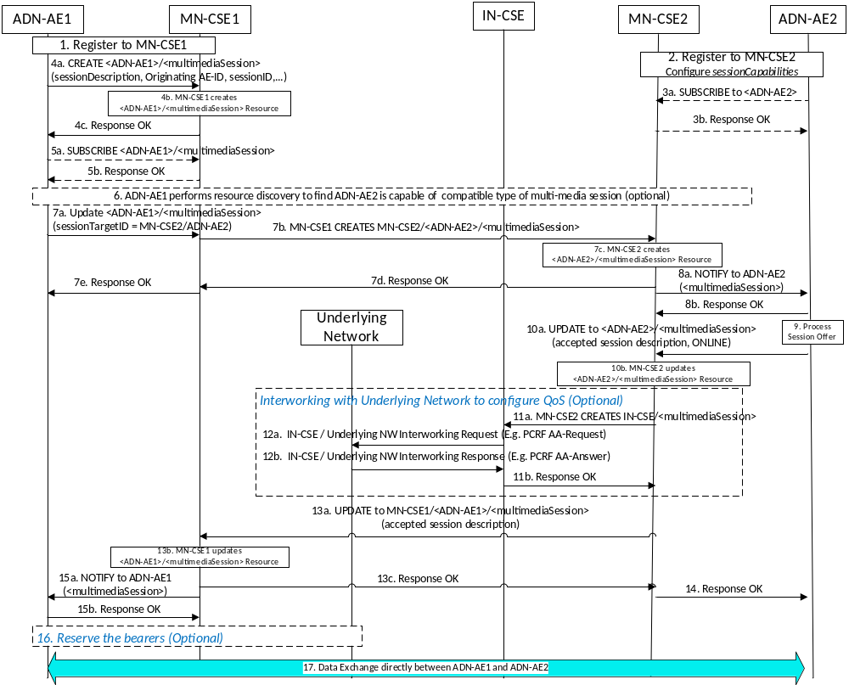
Figure 8.3.2.1-3: Establishing Real time multi-media session between ADN-AEs via MN-CSEs/IN-CSE

The following is a brief description of the steps in the call flow:
- In steps 1 and 2, the originating ADN-AE 1 and target ADN-AE 2 register to their corresponding MN-CSEs by creating resources of type <AE>. ADN-AE 2 also configures the sessionCapabilities attribute of its <ADN-AE2> resource to advertise its multimedia session capabilities such that other AEs can discover this information.
- In steps 3a and 3b, ADN-AE 2 subscribes to its <ADN-AE2> resource hosted in the MN-CSE 2 to receive notifications of multimedia session offers from originator AEs. Note, these steps may be optional if CSE supports sending notification to AE without a subscription when <multimediaSession> resource is created/update/deleted.
- In steps 4a-d, the originating ADN-AE 1 creates a child resource of type <multimediaSession> under its <ADN-AE1> resource hosted in the MN-CSE 1. This resource is configured with the session descriptions that ADN-AE 1 wishes to offer to target AEs.
- In steps 5a and 5b, ADN-AE 1 subscribes to its <multimediaSession> resource hosted in the MN-CSE 1 to receive notifications of multimedia session updates from target AEs . Note, these steps may be optional if CSE supports sending notification to AE without a subscription when <multimediaSession> resource is created/update/deleted.
- In step 6, ADN-AE 1 performs a resource discovery operation to query and find potential target AEs having desired multimedia sessionCapabilities that are compatible with its own. In this example, the response returns a URI of <ADN-AE2>.
- In steps 7a-c, ADN-AE 1 sends a multimedia session offer to ADN-AE 2. This is accomplished by ADN-AE 1 updating the sessionTargetID attribute of the MN-CSE1<ADN-AE1>/<multimediaSession> resource with the resourceID of <ADN-AE2>. The IN-CSE processes the update and as a result triggers the creation of a MN-CSE2/<ADN-AE2>/<multimediaSession> resource as a result.
- In steps 8a and 8b, the IN-CSE sends a notification to ADN-AE 2 containing the representation of the newly created MN-CSE2/<ADN-AE2>/<multimediaSession> resource.
- In step 9, ADN-AE 2 processes the notification, detects it is a multimedia session offer, examines the offered session descriptions and selects a session description that it wishes to accept.
- In steps 10a and 10b, ADN-AE 2 updates the MN-CSE2/<ADN-AE2>/<multimediaSession> resource based on the incoming offer and the session description it wishes to accept and changes the session state to ONLINE.
- In steps 11a and 11b, MN-CSE2 sends a CREATE Request based on the accepted offer to the IN-CSE to create a multimedia session resource on the IN-CSE to trigger it to configure the QoS on the underlying network.
- In steps 12a and 12b, the IN-CSE optionally interfaces with the underlying network (in this example the Rx reference point of the PCRF of a 3GPP LTE network) to configure the proper QoS for the corresponding multimedia session.
- In steps 13a-c, the MN-CSE2 updates the MN-CSE1/<ADN-AE1>/<multimediaSession> resource with the accepted offer.
- In steps 14, the MN-CSE2 returns a response to ADN-AE 2 indicating that the update was successful.
- In steps 15a and b the MN-CSE1 sends a notification to ADN-AE 1 indicating the session description that the target has agreed upon and changes the session state to ONLINE.
- In step 16, the originating ADN-AE 1 may need to reserve access bearers. This is optional.
- In step 17, ADN-AE 1 and ADN-AE 2 exchange media over the established multimedia session.

8.3.2.3 Example 3 – Updating an Established Multimedia Session
This example below shows the scenario where an established session between two ADNs require supdating. To update a multimedia session, the flow of media must first be stopped or be put on hold to enable the session to be updated. This can be accomplished by updating the session state of the corresponding oneM2M multimedia session resources which will result in the AEs pausing the media flow in the underlying network. Thereafter, the session description can be updated and the flow of media can be re-started by again by updating the state of the corresponding oneM2M multimedia session resources.
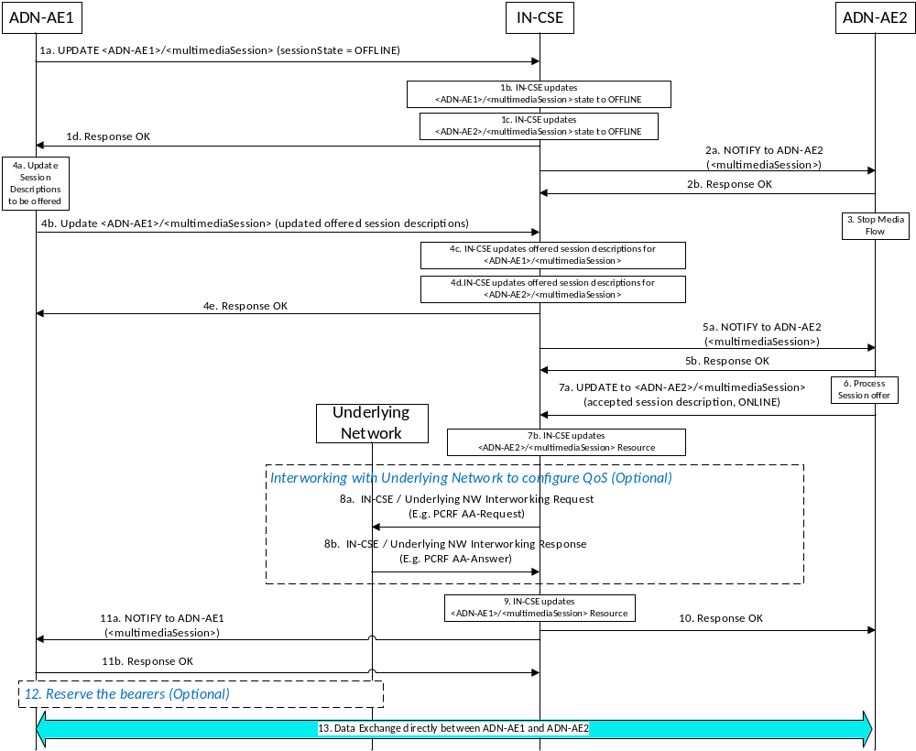
Figure 8.3.2.3-1: Updating Real time multimedia session between ADN-AEs via IN-CSE
The following is a brief description of the steps in the above call flow:
- In steps 1a-d, ADN-AE 1 sends an UPDATE request to the IN-CSE to modify the state of the multimedia session to OFFLINE. Upon receiving the request the IN-CSE first updates the session state of the <ADN-AE1>/<multimediaSession> resource and then updates the state of the <ADN-AE2>/<multimediaSession> resource as well.
- In steps 2a and 2b, the IN-CSE send a notification to ADN-AE 2 that includes the updated <multimediaSession> resource representation.
- In step 3, ADN-AE 2 processes the notification and detects that the multimedia session state has been changed to OFFLINE. As a result, ADN-AE 2 pauses its media flow.
- In steps 4a-e, ADN-AE 1 configures its updated session descriptions that it wants to offer and sends an UPDATE request to the IN-CSE to update the offered session descriptions. Upon receiving the request the IN-CSE first updates the offered session descriptions of the <ADN-AE1>/<multimediaSession> resource and then updates the same for the <ADN-AE2>/<multimediaSession> resource as well.
- In steps 5a and 5b, the IN-CSE send a notification to ADN-AE 2 that includes the updated <multimediaSession> resource representation.
- In step 6, ADN-AE 2 processes the notification and detects that the offered session descriptions have changed. As a result, ADN-AE 2 examines the offered session descriptions and selects a session description that it wishes to accept.
- In steps 7a and 7b, ADN-AE 2 updates the <ADN-AE2>/<multimediaSession> resource based on the incoming offer and the session description it wishes to accept. It also changes the session state to ONLINE.
- In steps 8a and 8b, the IN-CSE optionally interfaces with the underlying network (in this example the Rx reference point of the PCRF of a 3GPP LTE network) to configure the proper QoS for the corresponding accepted multimedia session description.
- In step 9, the IN-CSE updates the <ADN-AE1>/<multimediaSession> resource with the accepted offer.
- In step 10, the IN-CSE returns a response to ADN-AE 2 indicating that the update was successful.
- In steps 11a and b the IN-CSE sends a notification to ADN-AE 1 indicating the session description that the target has agreed upon and changes the session state to ONLINE.
- In step 12, the originating ADN-AE 1 may need to reserve access bearers. This is optional.
- In step 13, ADN-AE 1 and ADN-AE 2 exchange media over the established multimedia session.

8.3.3 Resource Types To Support Real Time Streaming Sessions

8.3.3.1Resource Type multimediaSession
An <multimediaSession> resource shall represent information about a multimedia session involving two AEs.

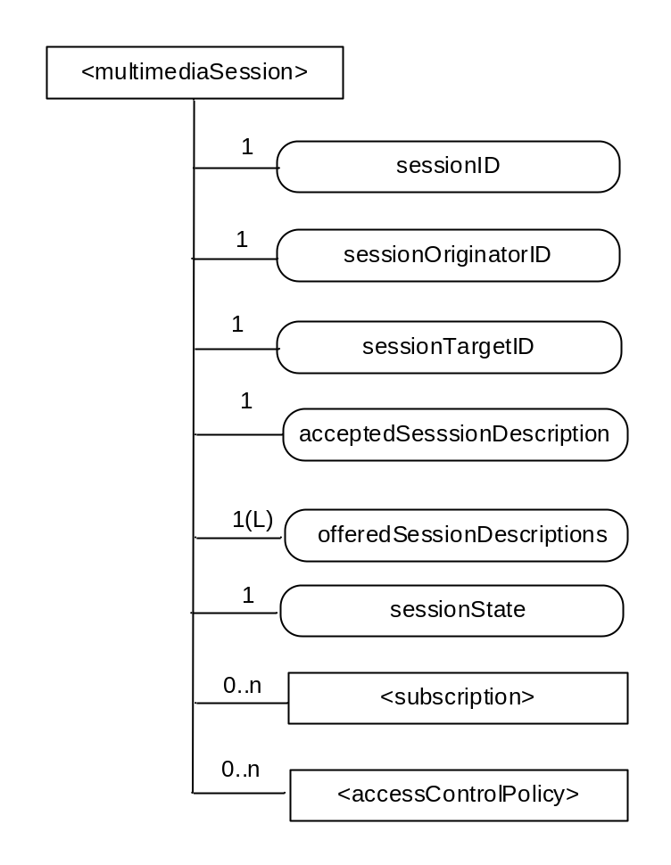
Figure 8.3.3.1-1: Structure of <multimediaSession> resource
The <multimediaSession> resource shall contain the child resources specified in table 8.3.3.1-1.

Table 8.3.3.1-1: Child resources of <multimediaSession > resource
Child Resources of < multimediaSession > | Child Resource Type |  | Multiplicity | Description | < multimediaSession Annc> Child Resource Types
[variable] | <subscription> | 0..n |  | See clause 9.6.8[i.2] | <subscription>
[variable] | <accessControlPolicy> | 0..n |  | See clause 9.6.2[i.2] | <accessControlPolicy>  <accessControlPolicyAnnc>

The <SS> resource shall contain the attributes specified in table 8.3.3.1-2.

Table 8.3.3.1-2: Attributes of <multimediaSession> resource
Attributes of  <multimediaSession> | Multiplicity | RW/  RO/  WO | Description | <multimediaSessionAnnc> Attributes
resourceType | 1 | RO | See clause 9.6.1.3[i.2] where this common attribute is described. | NA
resourceID | 1 | RO | See clause 9.6.1.3[i.2] where this common attribute is described. | MA
resourceName | 1 | WO | See clause 9.6.1.3[i.2] where this common attribute is described. | MA
parentID | 1 | RO | See clause 9.6.1.3[i.2] where this common attribute is described. | NA
expirationTime | 1 | RW | See clause 9.6.1.3[i.2] where this common attribute is described. | MA
accessControlPolicyIDs | 0..1 (L) | RW | See clause 9.6.1.3[i.2] where this common attribute is described. | MA
creationTime | 1 | RW | See clause 9.6.1.3[i.2] where this common attribute is described. | NA
lastModifiedTime | 1 | RO | See clause 9.6.1.3[i.2] where this common attribute is described. | NA
labels | 0..1 (L) | RO | See clause 9.6.1.3[i.2] where this common attribute is described. | MA
sessionID | 1 | RO | The sessionID shall be the same as the resourceID | NA
sessionOriginator ID | 1 | WO | The M2M identifier of the originator of the multimedia session. | NA
SessionTargetID | 1 | RW | The M2M identifier of the target of the multimedia session. | NA
acceptedSessionDescription | 1 | RW | Session description, including charateristics of the session t. The sessionDescription attribute is compliant to [i.3]. This is the the final accepted and agreed upon session description based on the received response from the target of the multimedia session. | NA
offeredSessionDescriptions | 1 | RW | A list of session descriptions offered by the originator of the session to the target. The attribute contains a list of session descriptors that are compliant to to [i.3]. | NA
sessionState | 1 | RW | The current state of the multimedia session. The supported values are ONLINE and OFFLINE. When the session is in the OFFLINE state, the corresponding AE session endpoints shall not initiate the flow of media between one another. When in the ONLINE state, the AEs are free to initiate the flow of media. | NA

8.3.4 Procedures

8.3.4.1 <multimediaSession> Resource Procedures

8.3.4.1.1 Create <multimediaSession>
This procedure shall be used for creating an <multimediaSession> resource.
Table 8.3.4.1.1-1: <multimediaSession> CREATE
<multimediaSession> CREATE
Associated Reference Point | Mca, and Mcc
Information in Request message | All parameters defined in table 8.1.2-2[i.2] apply with the specific details for:  To: Address of <AE>. Only an originating AE can create an multimediaSession resource over Mca.  For Mcc, the To address shall be set to the Address of <remote CSE> of the originating CSE . Only a registered CSE can create an multimediaSession resource over Mcc.  Content: The resource content shall provide the information as defined in clause 9.6.35[i.2]
Processing at Originator before sending Request | According to clause 10.1.1.1[i.2]
Processing at Receiver | According to clause 10.1.1.1[i.2] with the replacement for sub-step 1) of Step 002 as follows:  For a request over Mca, the Hosting CSE shall check if either the sessionOriginatorId or sessionTargetId attribute of the <multimediaSession> resource is the same as the AE-ID of the parent <AE> resource and If the check fails, the request shall be rejected. If the sessionTargetId is the same as the AE-ID of the parent resource, the hosting CSE shall check if the <AE> resource has a sessionCapabilities attribute that is set, and if not the request shall be rejected. If the sessionCapabilities attribute is set, the hosting CSE shall send a NOTIFY to the AE that includes the representation of the <multimediaSession> resource to inform it of an incoming multimedia session establishment request. This NOTIFY shall be sent by the Hosting CSE regardless of whether the AE has subscribed to the <AE> resource or not.  For a request over Mcc, the Hosting CSE shall check if the Originator ID is the same as the CSE-ID of the parent resource which is the <remoteCSE> resource and If the check fails, the request shall be rejected
Information in Response message | According to clause 10.1.1.1[i.2]
Processing at Originator after receiving Response | According to clause 10.1.1.1[i.2]
Exceptions | According to clause 10.1.1.1[i.2]

8.3.4.1.2 Retrieve < multimediaSession >
This procedure shall be used for retrieving the attributes of an < multimediaSession > resource.
Table 8.3.4.1.2-1: < multimediaSession > RETRIEVE
< multimediaSession > RETRIEVE
Associated Reference Point | Mca, and Mcc
Information in Request message | All parameters defined in table 8.1.2-2[i.2] apply.
Processing at Originator before sending Request | According to clause 10.1.2[i.2]
Processing at Receiver | According to clause 10.1.2[i.2]
Information in Response message | All parameters defined in table 8.1.3-1[i.2] apply.
Processing at Originator after receiving Response | According to clause 10.1.2[i.2]
Exceptions | According to clause 10.1.2[i.2]

8.3.4.1.3 Update < multimediaSession >
This procedure shall be used for updating attributes of an < multimediaSession > resource.
Table 8.3.4.1.3-1: < multimediaSession > UPDATE
< multimediaSession > UPDATE
Associated Reference Point | Mca, and Mcc
Information in Request message | All parameters defined in table 8.1.2-2[i.2] apply.  To modify (UPDATE) an ongoing session, the session shall be put on hold first by configuring the sessionState attribute to OFFLINE,, and after successful updating, it shall be resumed.
Processing at Originator before sending Request | According to clause 10.1.3[i.2]
Processing at Receiver | The Hosting CSE shall first check if the UPDATE is modifying the sessionTargetID, sessionState, offeredSessionDescriptions or acceptedSessionDescription attributes. If the request is not, then it will be processed according to clause 10.1.3[i.2]. Otherwise, the Hosting CSE will perform special handling of the UPDATE according to the following procedure.  - The Hosting CSE shall check if the sessionState attribute has a value of ONLINE. If ONLINE, and the UPDATE is not modifying sessionState to OFFLINE and the UPDATE is modifying sessionTargetID, offeredSessionDescriptions or acceptedSessionDescription then the Hosting CSE shall reject the request and return and error to the originator. Otherwise the Hosting CSE shall perform the UPDATE.  - If the UPDATE is performed, the Hosting CSE shall check whether the targeted <multimediaSession> resource is a child of an <AE> resource and if the UPDATE results in the modification of the sessionTargetID. If so, the Hosting CSE shall initiate a CREATE request to the sessionTargetID to create a peer <multimediaSession> resource. This CREATE may be local on the same CSE or target a remote CSE one or more hops away.  - If the UPDATE is performed, the Hosting CSE shall check whether the targeted <multimediaSession> resource is a child of an <AE> resource and if so whether the originator’s ID is equal to the AE-ID of the parent <AE> resource. If they are not the same, the Hosting CSE shall send a NOTIFY to the AE corresponding to the parent <AE> resource to inform it that an update to its <multimediaSession> resource has occurred. This NOTIFY shall be sent by the Hosting CSE regardless of whether the AE has subscribed to the <AE> resource or not.  - If the UPDATE is performed, and the UPDATE results in a modification of sessionState, offeredSessionDescriptions or acceptedSessionDescription, the Hosting CSE shall check whether the targeted <multimediaSession> resource is a child of an <AE> resource. If so, the Hosting CSE shall initiate an UPDATE to the peer <multimediaSession> resource to keep it synchronized. To do this, the Hosting CSE shall compare the AE-ID associated with the parent <AE> resource of the updated <multimediaSession> resource to the sessionOriginatorID and sessionTargetID to determine which one does not match. The Hosting CSE shall then send an UPDATE request to the <multimediaSession> child resource corresponding to this ID. This UPDATE may be local on the same CSE or target a remote CSE one or more hops away.  If the UPDATE is performed, and the UPDATE results in a modification of acceptedSessionDescription, the Hosting CSE shall check whether the targeted <multimediaSession> resource is a child of an <AE> resource having an AE-ID that corresponds to the sessionTargetID. If so, the Hosting CSE may initiate configuration of the QoS parameters in the underlying network. If the Hosting CSE is the IN-CSE, it may interwork with the underlying network to configure the QoS. If the Hosting CSE is not the IN-CSE, it may send a <multimediaSession> CREATE request to the IN-CSE to trigger it to interwork with the underlying network. The CREATE request may traverse one or more hops and may target the <remoteCSE> resource of the Hosting CSE or its registrar CSE depending on the number of hops traversed.
Information in Response message | According to clause 10.1.3[i.2]
Processing at Originator after receiving Response | According to clause 10.1.3[i.2]
Exceptions | According to clause 10.1.3[i.2]

8.3.4.1.4 Delete <multimediaSession>
This procedure shall be used for deleting an <multimediaSession> resource .
Table 8.3.4.1.4-1: <multimediaSession> DELETE
<multimediaSession> DELETE
Associated Reference Point | Mca, and Mcc
Information in Request message | All parameters defined in table 8.1.2-2[i.2] apply
Processing at Originator before sending Request | According to clause 10.1.4.1[i.2]
Processing at Receiver | According to clause 10.1.4.1[i.2]  The Hosting CSE will perform special handling of the DELETE according to the following procedure.  - The Hosting CSE shall check whether the targeted <multimediaSession> resource is a child of an <AE> resource. If so, the Hosting CSE shall initiate a DELETE to the peer <multimediaSession> resource to keep it synchronized. To do this, the Hosting CSE shall compare the AE-ID associated with the parent <AE> resource of the <multimediaSession> resource to be deleted with its the sessionOriginatorID and sessionTargetID to determine which one does not match. The Hosting CSE shall then send a DELETE request to the <multimediaSession> child resource corresponding to this ID. This DELETE may be local on the same CSE or target a remote CSE one or more hops away.  - If the DELETE is performed, the Hosting CSE shall check whether the targeted <multimediaSession> resource is a child of an <AE> resource and if so whether the originator’s ID is equal to the AE-ID of the parent <AE> resource. If they are not the same, the Hosting CSE shall send a NOTIFY to the AE corresponding to the parent <AE> resource to inform it that its <multimediaSession> resource has been deleted. This NOTIFY shall be sent by the Hosting CSE regardless of whether the AE has subscribed to the <AE> resource or not.  - If the DELETE is performed, the Hosting CSE shall check whether the targeted <multimediaSession> resource is a child of an <AE> resource having an AE-ID that corresponds to the sessionTargetID. If so, the Hosting CSE may initiate tear-down of the QoS parameters in the underlying network. If the Hosting CSE is the IN-CSE, it may interwork with the underlying network to tear down the QoS configuration. If the Hosting CSE is not the IN-CSE, it may send a <multimediaSession> DELETE request to the IN-CSE to trigger it to interwork with the underlying network. The DELETE request may traverse one or more hops and shall target the <remoteCSE> resource of the Hosting CSE, its registrar CSE depending on the number of hops traversed.
Information in Response message | According to clause 10.1.4.1[i.2]
Processing at Originator after receiving Response | According to clause 10.1.4.1[i.2]
Exceptions | According to clause 10.1.4.1[i.2]

8.3.5 Changes to existing Resources in TS-0001
This section includes the changes needed in TS-0001 in existing resources and Tables to support the above. Imapcted sections in TS-0001 will be shown using the applicable section number.
9.6 Resource Types
Add the following info in Table 9.6.1.1-1[i.2] Resource Types
Table 9.6.1.1-1 Resource Types
Resource Type | Short Description | Child Resource Types | Parent Resource Types | Clause
multimediaSession | Stores a representation of a multimedia session information requested by a registering AE | Subscription, accessControlPolicy | AE for request over Mca, or remoteCSE for request over Mcc | 8.3.3

9.6.4 Resource Type remoteCSE

A <remoteCSE> resource shall represent a Registree CSE that is registered to the Registrar CSE. <remoteCSE> resources shall be located directly under the <CSEBase> resource of Registrar CSE.
Similarly <remoteCSE> resource shall also represent a Registrar CSE. <remoteCSE> resource shall be located directly under the <CSEBase> resource of Registree CSE.
For example, when CSE1 (Registree CSE) registers with CSE2 (Registrar CSE), there will be two <remoteCSE> resources created: one in CSE1: <CSEBase1>/<remoteCSE2> and one in CSE2: <CSEBase2>/<remoteCSE1>.
Note that the creation of the two resources does not imply mutual registration. The <CSEBase1>/<remoteCSE2> does not mean CSE2 registered with CSE1 in the example above.
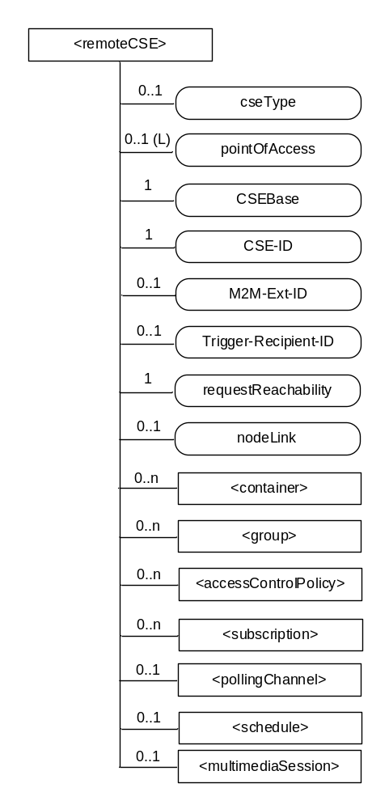
Figure 9.6.4-1: Structure of <remoteCSE> resource

The <remoteCSE> resource shall contain the child resources specified in table 9.6.4-1. The <remoteCSE> resource may contain <remoteCSEAnnc> child resources.
Table 9.6.4-1: Child resources of <remoteCSE> resource
Child Resources of <remoteCSE> | Child Resource Type | Multiplicity | Description | <remoteCSEAnnc> Child Resource Types
[variable] | <container> | 0..n | See clause 9.6.6[i.2] | <container> <containerAnnc>
[variable] | <group> | 0..n | See clause 9.6.13[i.2] | <group>  <groupAnnc>
[variable] | <accessControlPolicy> | 0..n | See clause 9.6.2[i.2] | <accessControlPolicy>  <accessControlPolicyAnnc>
[variable] | <subscription> | 0..n | See clause 9.6.8[i.2] | <subscription>
[variable] | <pollingChannel> | 0..1 | See clause 9.6.21[i.2]. If requestReachability is FALSE, the CSE that created this <remoteCSE> resource should create a <pollingChannel> resource and perform long polling. The <pollingChannel> shall be utilized by the the parent resource. | None
[variable] | <schedule> | 0..1 | This resource defines the reachability schedule information of the node. See clause 9.6.9[i.2] for <schedule>. | <scheduleAnnc>
[variable] | < multimediaSession> |  | See Clause 8.3.3. This resources holds information describing the established multimedia session | NA
[variable] | <nodeAnnc> | 0..n | This resource is the <nodeAnnc> resource representing the node where the CSE represented by this <remoteCSE> resource resides. | <nodeAnnc>

Table 9.6.4-2: Child announced resources of <remoteCSE> resource
Child Announced Resources of <remoteCSE> | Child Announced Resource Type | Multiplicity | Description
[variable] | Refer to table 9.6.26.1-1[i.2] Announced Resource Types | 0..n

The <remoteCSE> resource shall contain the attributes specified in table 9.6.4-3.
Table 9.6.4-3: Attributes of <remoteCSE> resource
Attributes of <remoteCSE> | Multiplicity | RW/  RO/  WO | Description | <remoteCSEAnnc> Attributes
resourceType | 1 | RO | See clause 9.6.1.3[i.2] where this common attribute is described. | NA
resourceID | 1 | RO | See clause 9.6.1.3[i.2] where this common attribute is described. | NA
resourceName | 1 | WO | See clause 9.6.1.3[i.2] where this common attribute is described. | NA
parentID | 1 | RO | See clause 9.6.1.3[i.2] where this common attribute is described. | NA
creationTime | 1 | RO | See clause 9.6.1.3[i.2] where this common attribute is described. | NA
lastModifiedTime | 1 | RO | See clause 9.6.1.3[i.2] where this common attribute is described. | NA
expirationTime | 1 | RW | See clause 9.6.1.3[i.2] where this common attribute is described. | MA
accessControlPolicyIDs | 0..1 (L) | RW | See clause 9.6.1.3[i.2] where this common attribute is described. | MA
labels | 0..1 (L) | RW | See clause 9.6.1.3[i.2] where this common attribute is described. | MA
announceTo | 0..1 (L) | RW | See clause 9.6.1.3[i.2] where this common attribute is described. | NA
announcedAttribute | 0..1 (L) | RW | See clause 9.6.1.3[i.2] where this common attribute is described. | NA
cseType | 0..1 | WO | Indicates the type of CSE represented by the created resource.  - Mandatory for an IN-CSE, hence multiplicity (1).  - Its presence is subject to SP configuration in case of an ASN-CSE or a MN-CSE. | OA
pointOfAccess | 0..1 (L) | RW | For request-reachable remote CSE it represents the list of physical addresses to be used to connect to it (e.g. IP address, FQDN). The attribute is absent if the remote CSE is not request-reachable.  If this information is not provided, the CSE should use <pollingChannel> resource. Then the Hosting CSE can forward a request to the CSE without using the PoA. | OA
CSEBase | 1 | WO | The address of the CSEBase resource represented by this <remoteCSE> resource. | OA
CSE-ID | 1 | WO | The CSE identifier in SP-relative CSE-ID format (clause 7.2[i.2]). | OA
M2M-Ext-ID | 0..1 | RW | Supported when Registrar is IN-CSE.  See clause 7.1.8[i.2] where this attribute is described. This attribute is used only for the case of dynamic association of M2M-Ext-ID and CSE-ID. | NA
Trigger-Recipient-ID | 0..1 | RW | Supported when Registrar is IN-CSE. See clause 7.1.10[i.2] where this attribute is described. This attribute is used only for the case of dynamic association of M2M-Ext-ID and CSE-ID. | NA
requestReachability | 1 | RW | If the CSE that created this <remoteCSE> resource can receive a request from other AE/CSE(s), this attribute is set to "TRUE" otherwise "FALSE" (see note) | OA
nodeLink | 0..1 | RW | The resourceID of a <node> resource that hosts the CSE represented by the <remoteCSE> resource. | OA
NOTE: Even if this attribute is set to "FALSE", it does not mean it AE/CSE is always unreachable by all entities. E.g. the requesting AE/CSE is behind the same NAT, so it can communicate within the same NAT.

9.6.5 Resource Type AE
An <AE> resource shall represent information about an Application Entity registered to a CSE.

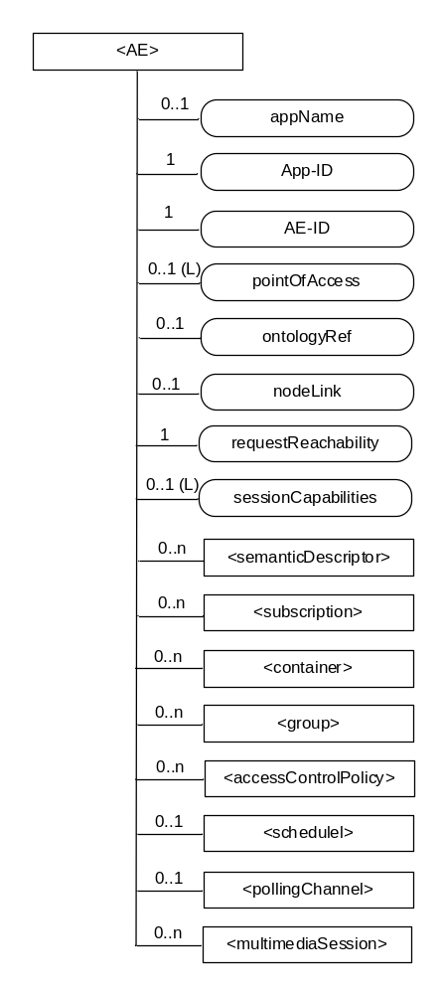
Figure 9.6.5-1: Structure of <AE> resource
The <AE> resource shall contain the child resources specified in table 9.6.5-1.
Table 9.6.5-1: Child resources of <AE> resource
Child Resources of <AE> | Child Resource Type | Multiplicity | Description | <AEAnnc> Child Resource Types
semanticDescriptor | <semanticDescriptor> | 0..n | See clause 9.6.30[i.2] | <semanticDescriptor>, <semanticDescriptorAnnc>
[variable] | <subscription> | 0..n | See clause 9.6.8[i.2] | <subscription>
[variable] | <container> | 0..n | See clause 9.6.6[i.2] | <container> <containerAnnc>
[variable] | <group> | 0..n | See clause 9.6.13[i.2] | <group>  <groupAnnc>
[variable] | <accessControlPolicy> | 0..n | See clause 9.6.2[i.2] | <accessControlPolicy>  <accessControlPolicyAnnc>
[variable] | <schedule> | 0..1 | See clause 9.6.9[i.2] | <scheduleAnnc>
[variable] | <pollingChannel> | 0..1 | See clause 9.6.21[i.2].  When the AE is request-unreachable, the AE should create this <pollingChannel> resource and perform long polling. The <pollingChannel> shall be utilized by the the parent resource. | None
variable] | < multimediaSession> |  | See Clause 8.3.3. This resources holds information describing the established multimedia session | NA

The <AE> resource shall contain the attributes specified in table 9.6.5-2.
Table 9.6.5-2: Attributes of <AE> resource
Attributes of  <AE> | Multiplicity | RW/  RO/  WO | Description | <AEAnnc> Attributes
resourceType | 1 | RO | See clause 9.6.1.3[i.2]. | NA
resourceID | 1 | RO | See clause 9.6.1.3[i.2]. Contains the AE-ID-Stem of the AE (see clause 7.2[i.2] on identifier formats and clause 10.1.1.2.2[i.2] for AE registration procedure). | NA
resourceName | 1 | WO | See clause 9.6.1.3[i.2]. | NA
parentID | 1 | RO | See clause 9.6.1.3[i.2]. | NA
expirationTime | 1 | RW | See clause 9.6.1.3[i.2]. | MA
accessControlPolicyIDs | 0..1 (L) | RW | See clause 9.6.1.3[i.2]. | MA
creationTime | 1 | RO | See clause 9.6.1.3[i.2]. | NA
lastModifiedTime | 1 | RO | See clause 9.6.1.3[i.2]. | NA
labels | 0..1 (L) | RW | See clause 9.6.1.3[i.2]. | MA
announceTo | 0..1 (L) | RW | See clause 9.6.1.3[i.2]. | NA
announcedAttribute | 0..1 (L) | RW | See clause 9.6.1.3[i.2]. | NA
appName | 0..1 | RW | The name of the application, as declared by the application developer(e.g. "HeatingMonitoring").  Several sibling resources may share the appName. | OA
App-ID | 1 | WO | The identifier of the Application (see clause 7.1.2[i.2]). | OA
AE-ID | 1 | RO | The identifier of the Application Entity (see clause 7.1.2[i.2]). | OA
pointOfAccess | 0..1 (L) | RW | The list of addresses for communicating with the registered Application Entity over Mca reference point via the transport services provided by Underlying Network (e.g. IP address, FQDN, URI). This attribute shall be accessible only by the AE and the Hosting CSE.  If this information is not provided, the AE should use <pollingChannel> resource. Then the Hosting CSE can forward a request to the AE without using the PoA. | OA
ontologyRef | 0..1 | RW | A URI of the ontology used to represent the information that is managed and understood by the AE. | OA
requestReachability | 1 | RW | If the AE that created this <AE> resource can receive a request, this attribute is set to "TRUE" otherwise "FALSE" | OA
nodeLink | 0..1 | RO | The resourceID of a <node> resource that stores the node specific information where the AE resides. | OA
sessionCapabilities | 0..1 (L) | RW | The list of supported session media types (e.g. audio, video, image) and supported session protocols (e.g. RTP, RTP/AVP) as defined by session parameters as defined by the IETF IANA Session Descriptor Protocol (SDP) Parameter Registry. | OA

The following text is to be used when appropriate:

Proforma copyright release text block
This text box shall immediately follow after the heading of an element (i.e. clause or annex) containing a proforma or template which is intended to be copied by the user. Such an element shall always start on a new page.
Notwithstanding the provisions of the copyright clause related to the text of the present document, oneM2M grants that users of the present document may freely reproduce the <proformatype> proforma in this {clause|annex} so that it can be used for its intended purposes and may further publish the completed <proformatype>.
<PAGE BREAK>

Annexes
Each annex shall start on a new page (insert a page break between annexes A and B, annexes B and C, etc.).
Use the Heading 9 style for the title and the Normal style for the text.
Annex <A>:
Title of annex (style H9)
<Text>
<PAGE BREAK>
Annex <B>:
Title of annex (style H9)
<Text>
B.1 First clause of the annex (style H1)
<Text>
B.1.1 First subdivided clause of the annex (style H2)
<Text>
<PAGE BREAK>

Annex <y>:
Bibliography
The annex entitled "Bibliography" is optional.
It shall contain a list of standards, books, articles, or other sources on a particular subject which are not mentioned in the document itself.
It shall not include references mentioned in the document.
Use the Heading 9 style for the title and B1+ or Normal for the text.
- <Publication>: "<Title>".
OR
<Publication>: "<Title>".
<PAGE BREAK>

History
This clause shall be the last one in the document and list the main phases (all additional information will be removed at the publication stage).
Publication history
V.1.1.1 | <dd Mmm yyyy> | <Milestone>

Draft history (to be removed on publication)
V.0.0.1 | 20 July 2015 | Initial skeleton
V.0.1.0 | 19 October 2015 | Incorporated contributions:  ARC-2015-2108R01-TR-0020_Existing_of_requirements  ARC-2015-2107-TR-0020_Reusable_service_layer_context_introduction
V.0.2.0 | 28 November 2015 | Incorporated contributions:  ARC-2015-2264R02-TR-0020 Function of supporting re-usable service layer context  ARC-2015-2233R02-Streaming-Session-Support
V.0.3.0 | 14 February 2016 | Incorporated contributions:  ARC-2016-0074R03-Multimedia-Session-Updates-TR-0020
V.0.4.0 | 30 May 2016 | Changed the references in clause 8.3.3, 8.3.4 and 8.3.5.  Incorporated contributions:  ARC-2016-0269-TR0020_introduction_to_transaction  ARC-2016-0270-TR0020_technology_related_to_transaction
V.0.5.0 | 08 November 2016 | Incorporated contributions:  ARC-2016-0452-Transaction_in_REST  ARC-2016-0453R01-architecture_of_transaction
V.0.6.0 | 09 December 2016 | Incorporated contributions:  ARC-2016-0454R01-potential_transaction_solution_in_oneM2M
V.0.7.0 | 01 April 2017 | Incorporated contributions:  ARC-2017-0123R01-CR-TR-0020-Group_Fanout_of_Transactions  ARC-2017-0143R02-TR-0020_potential_solution_for_transaction_support
V.0.8.0 | 02 June 17 | Incorporated contributions:  ARC-2017-0194R01-TR-0020_transaction_management_solution

